**Demo- Create Machine Learning Model with IBM Watson Studio service**

**Step1 – Login to IBM Cloud** [**https://cloud.ibm.com/login**](https://cloud.ibm.com/login)

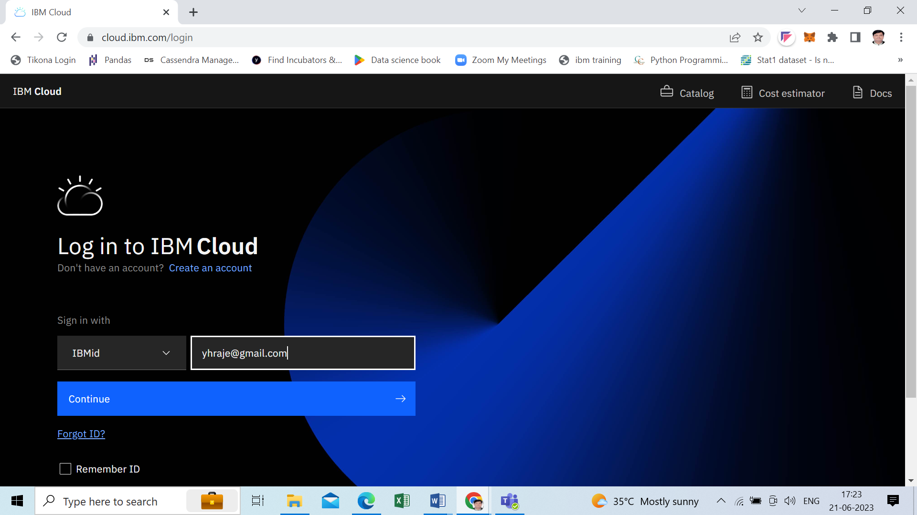

**After Login, you will be redirected to Dashboard**

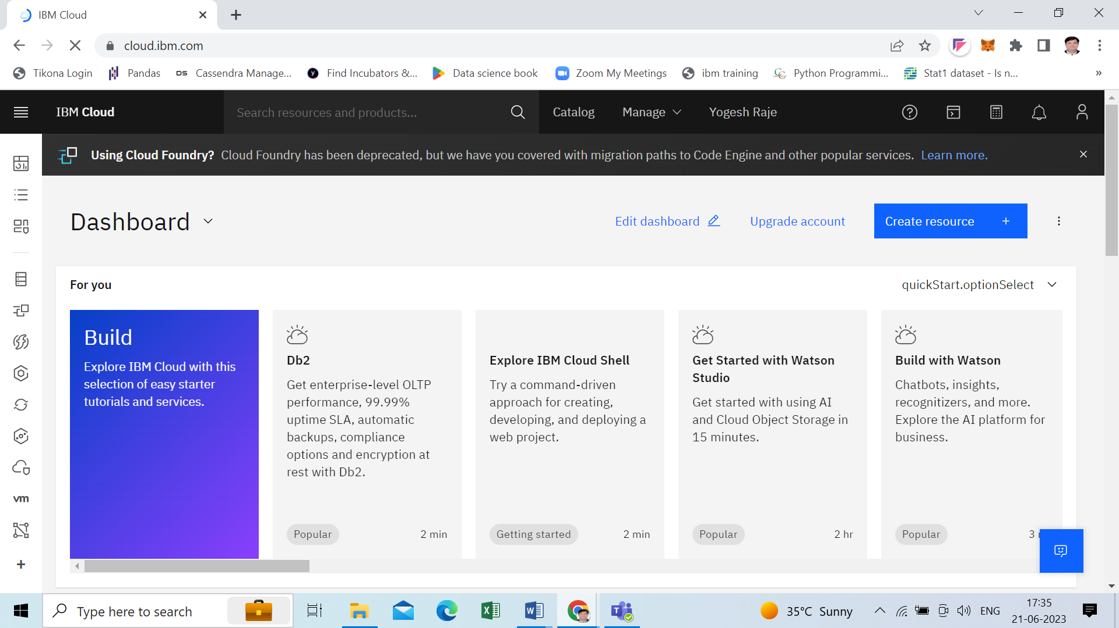

**Step2 – create IBM Watson Studio Service**

**In dashboard search for Watson studio**

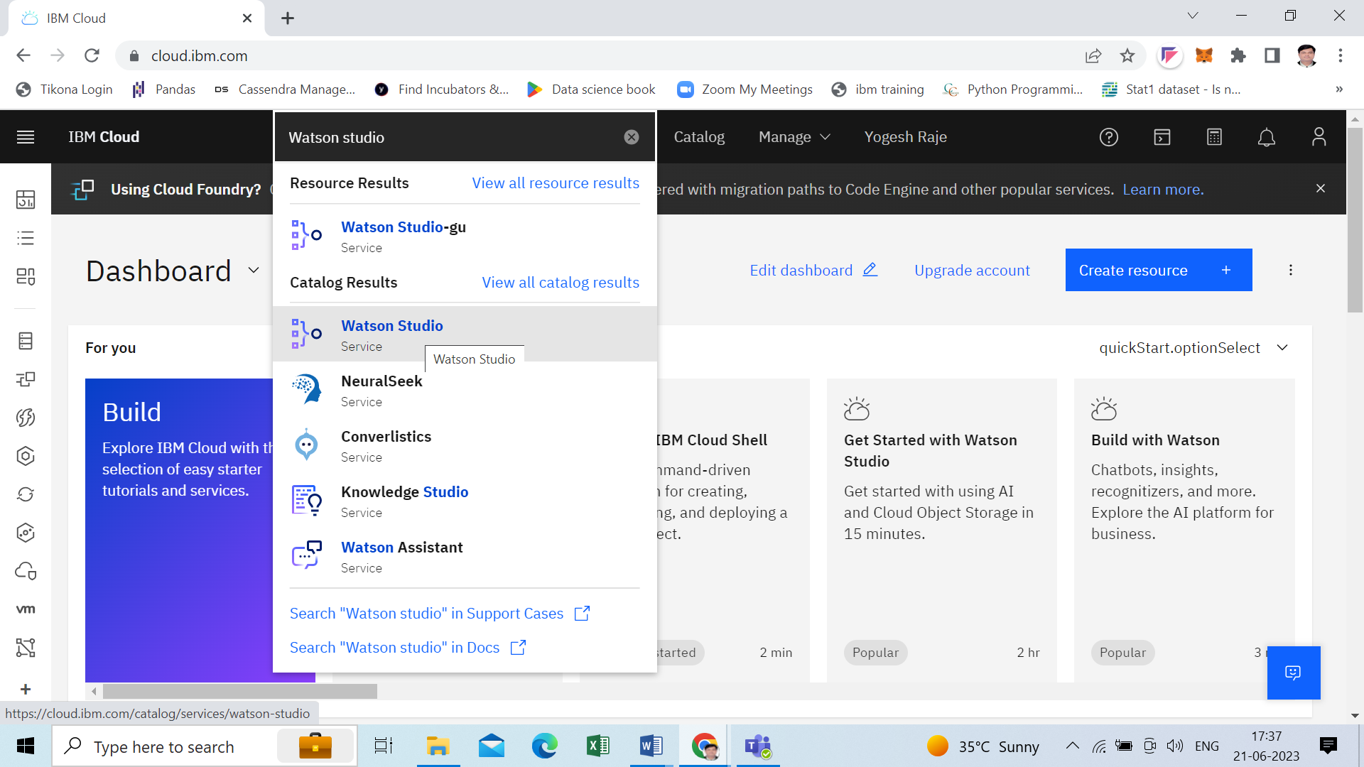

**Select Location= Dallas(us-south) and click on Create Button**

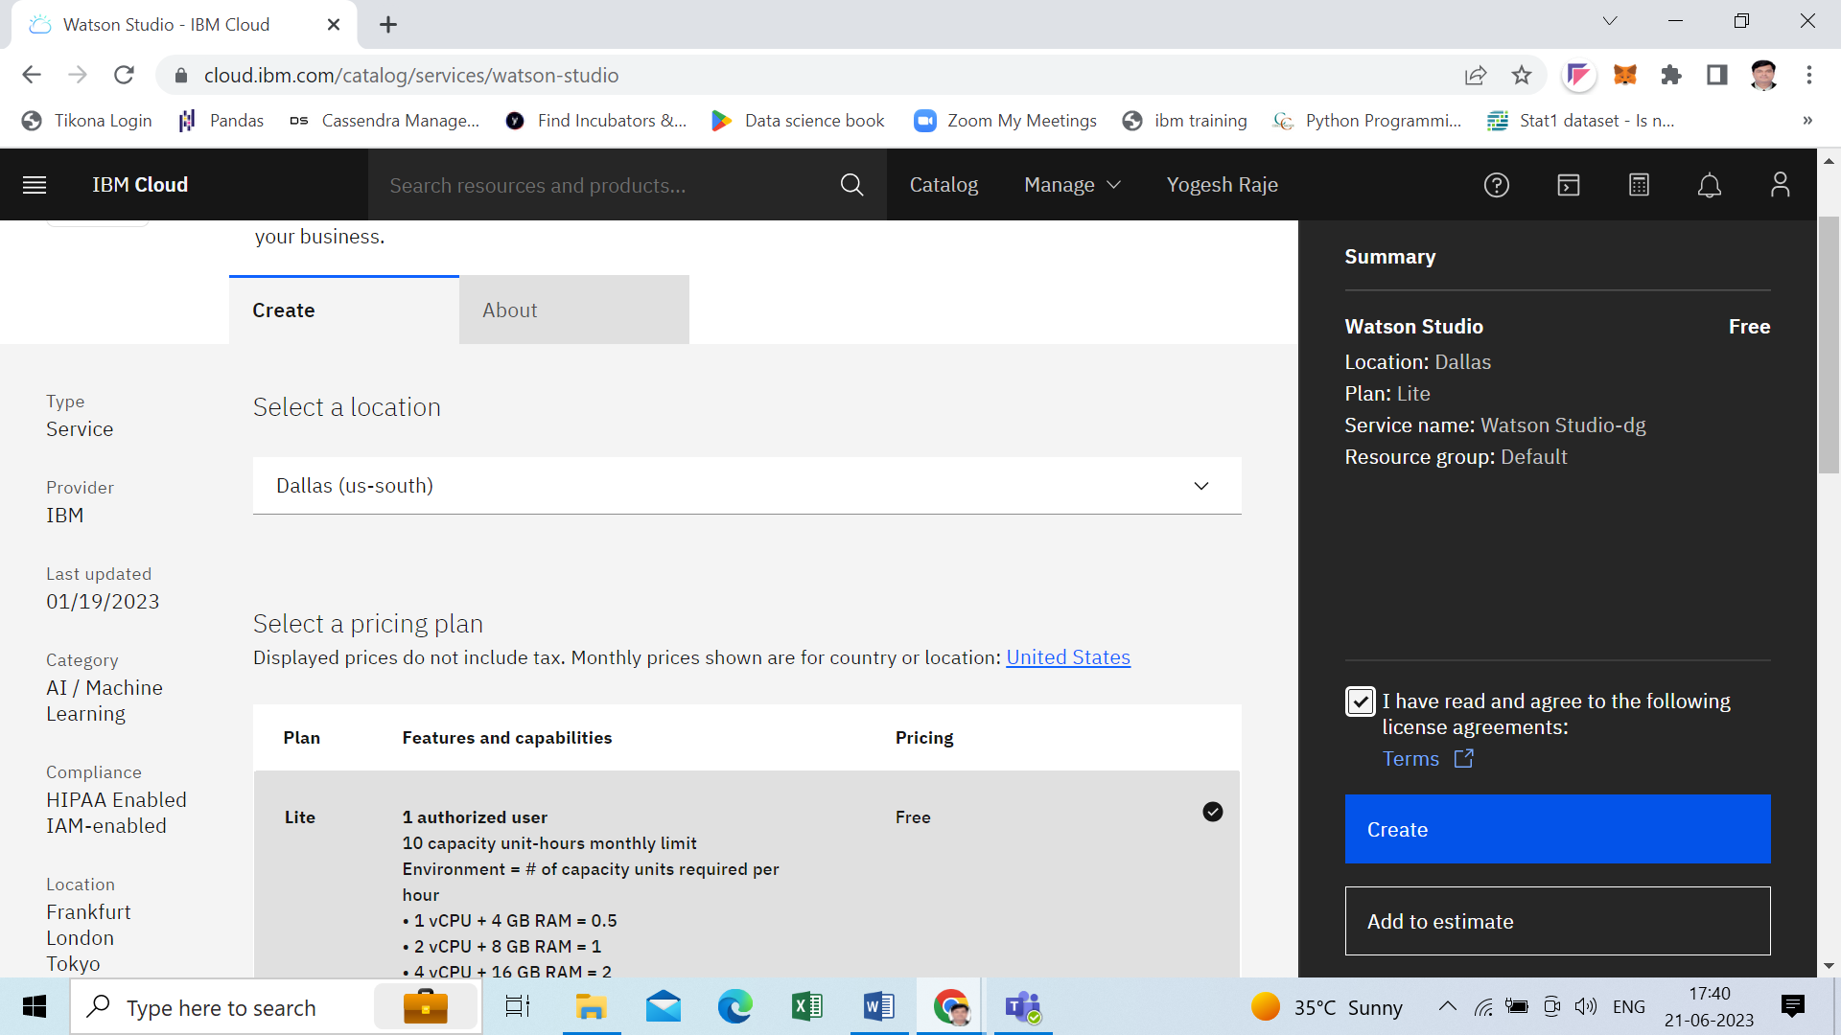

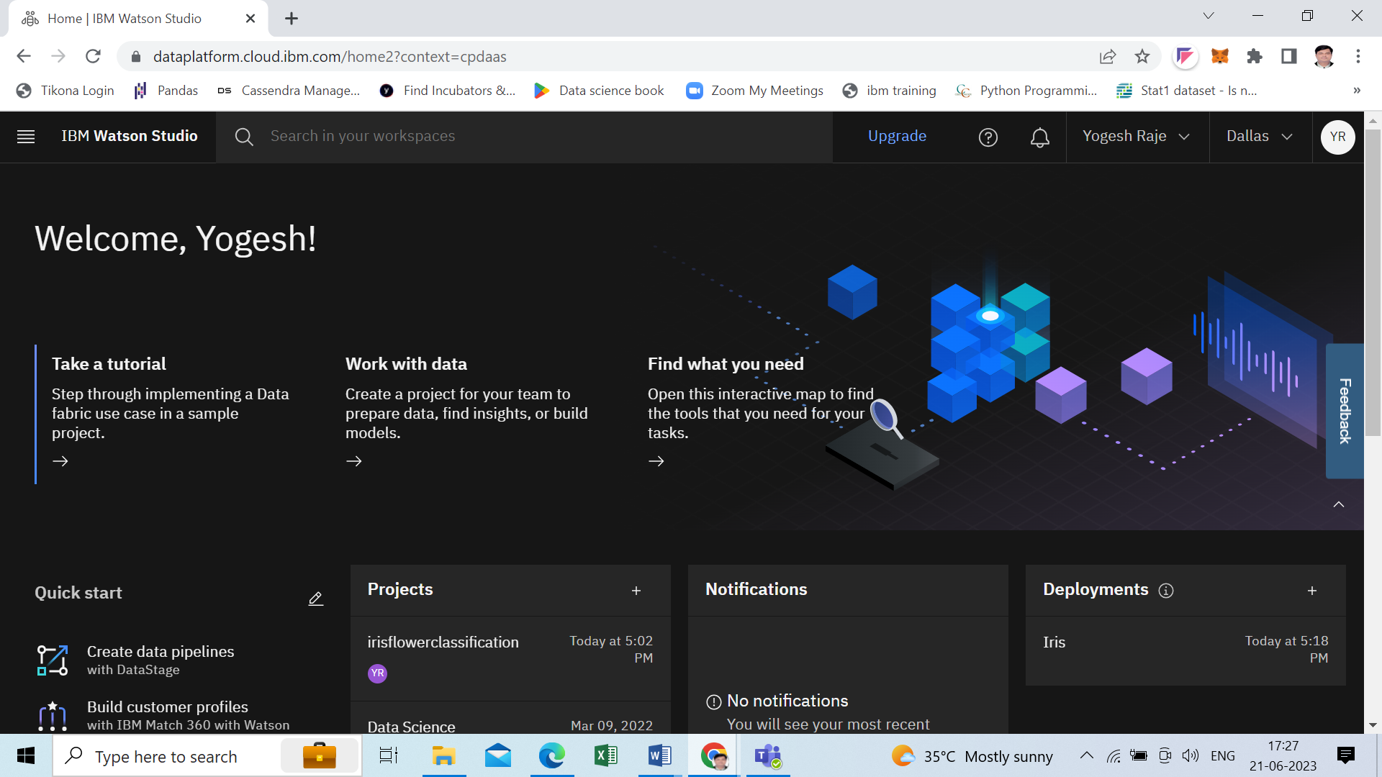

**Step3 – Create new project**

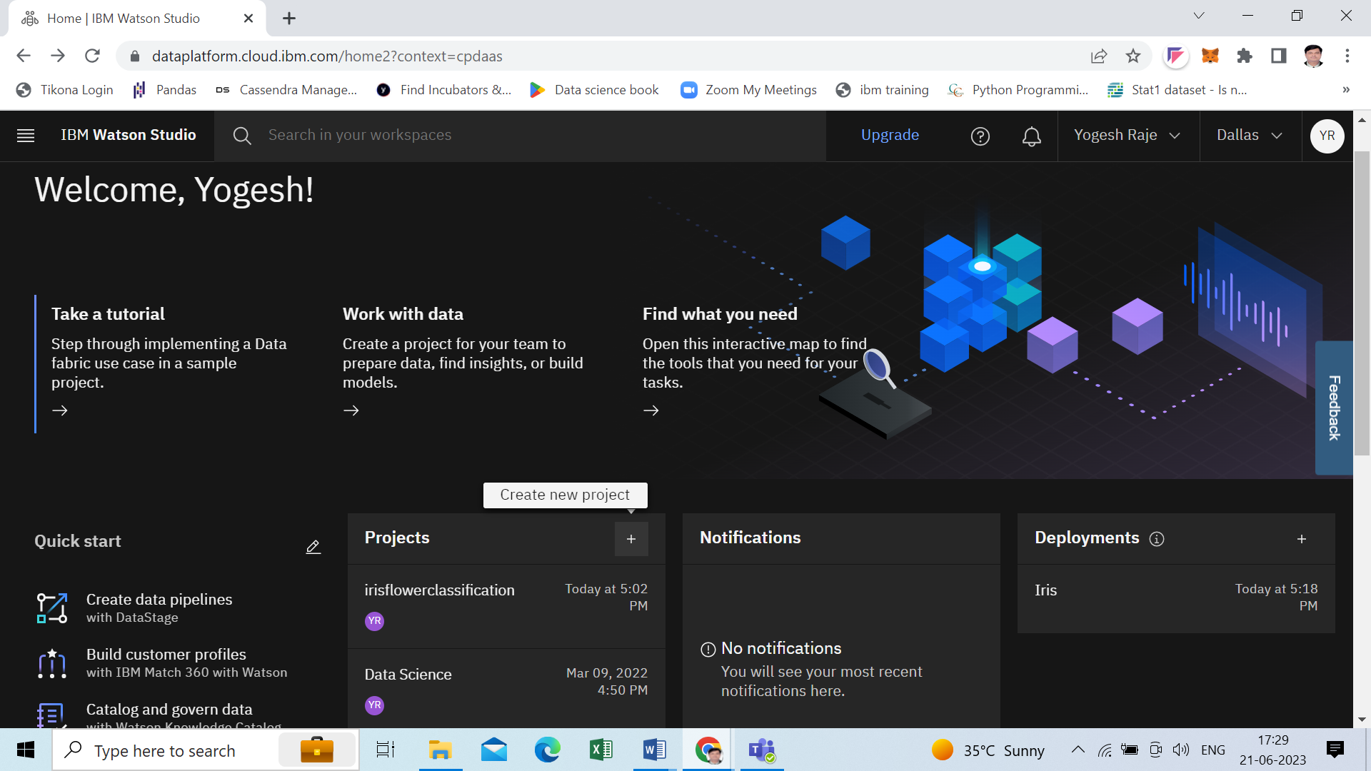

IBM Cloud Pak for Data is a modular set of integrated software components for data analysis, organization and management. It is available for self-hosting, or as a managed service on [IBM Cloud](https://www.ibm.com/cloud), connected to your data through [IBM Cloud Satellite](https://www.ibm.com/products/satellite).

watsonx is an AI and data platform with a set of AI assistants designed to help you scale and accelerate the impact of AI with trusted data across your business.

The core components include: a studio for new foundation models, generative AI and machine learning; a fit-for-purpose data store built on an open data lakehouse architecture; and a  toolkit, to accelerate AI workflows that are built with responsibility, transparency and explainability.

The watsonx AI assistants empower individuals in your organization to do work without expert knowledge across a variety of business processes and applications, including automating customer service, generating code, and automating key workflows in departments such as HR.

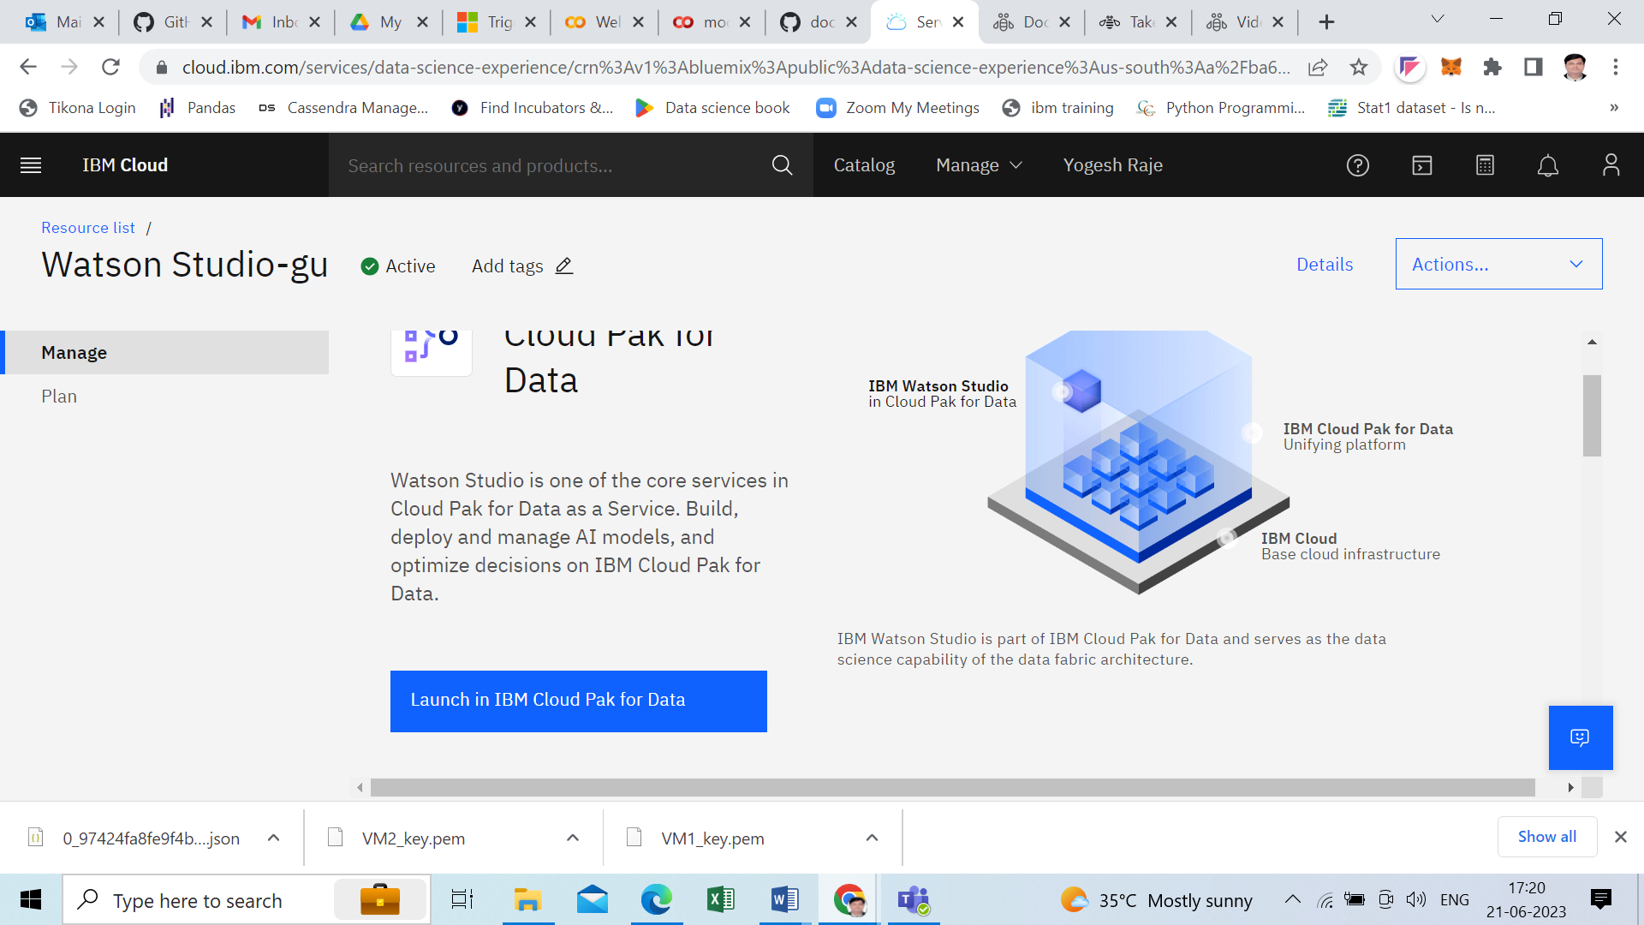

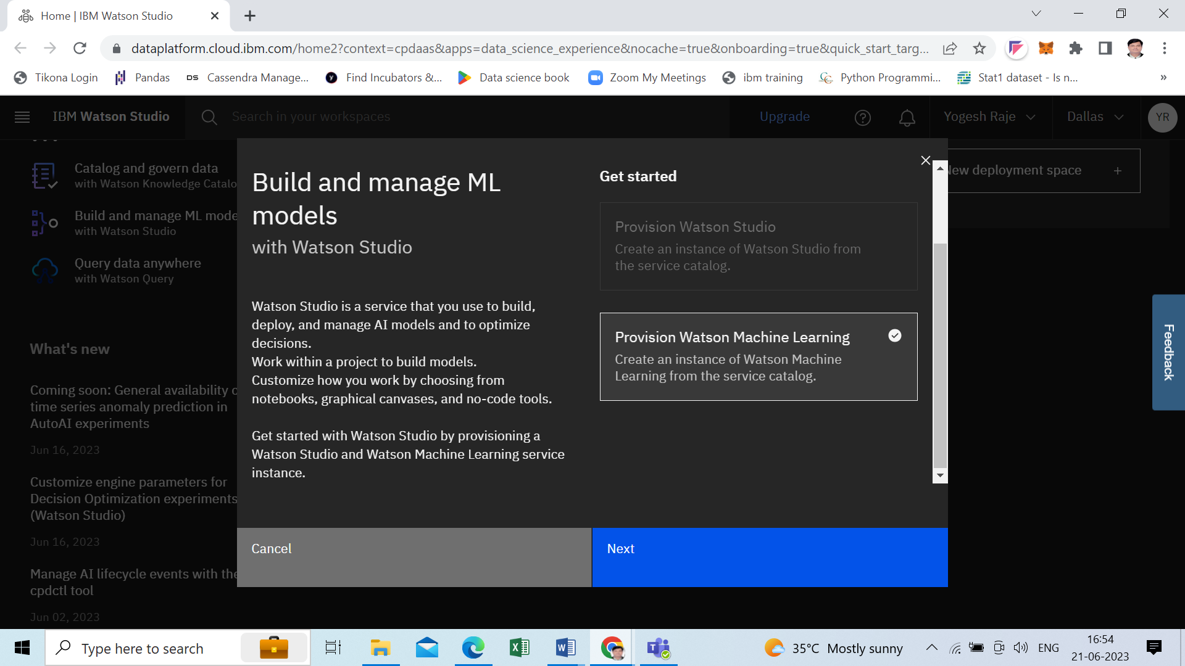

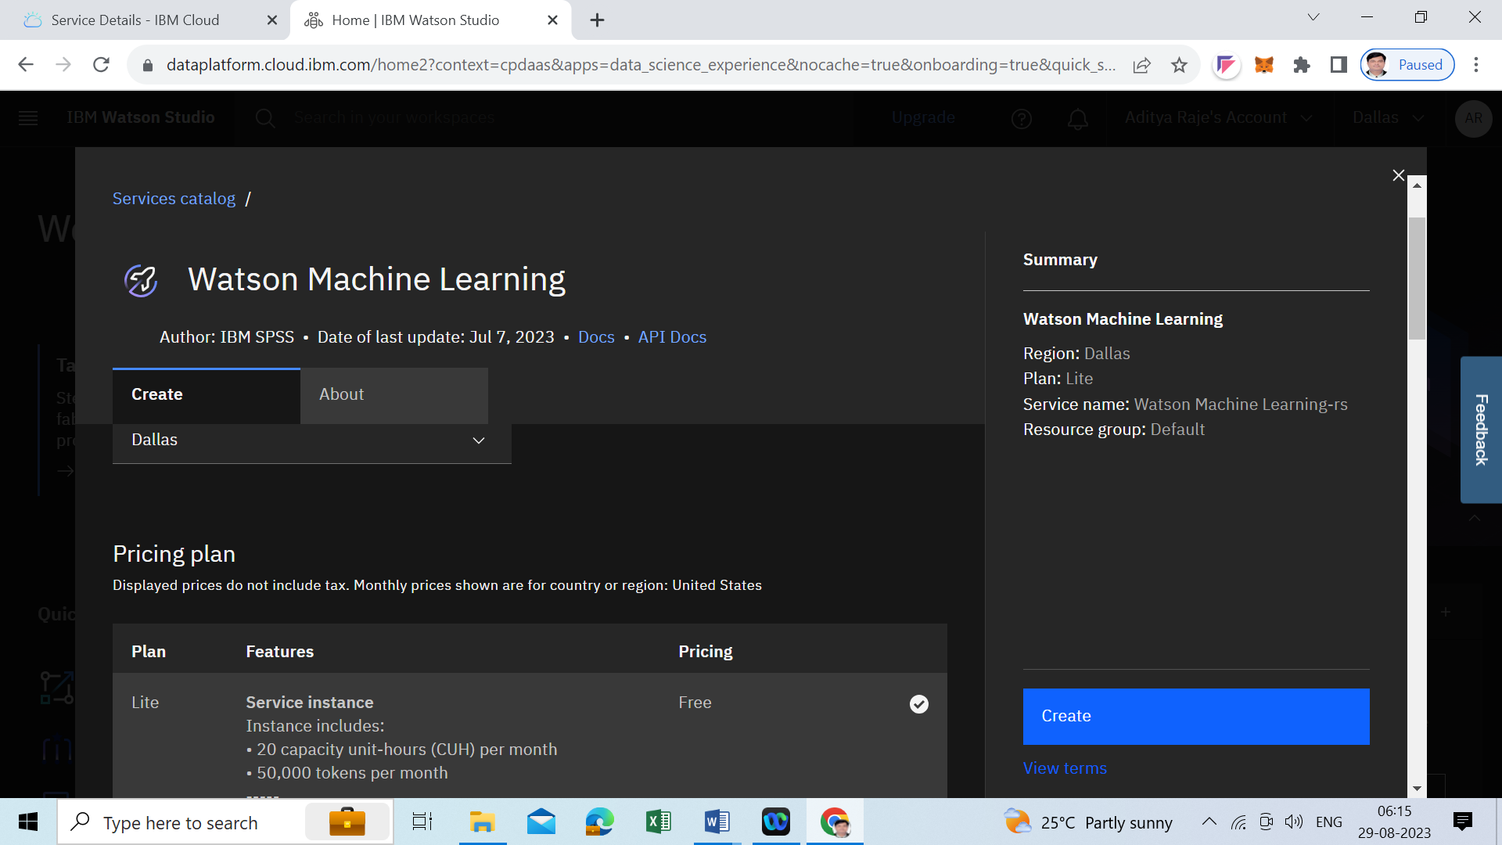

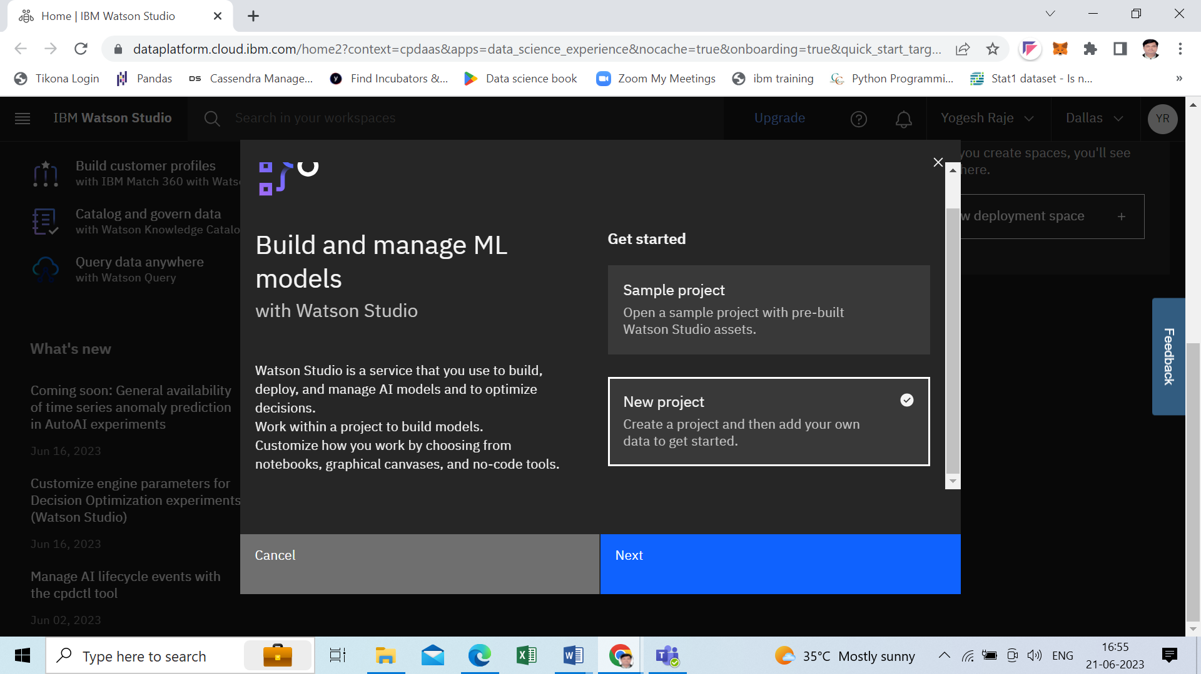

Step4- Add project details and click on **Add** link to **select storage service**

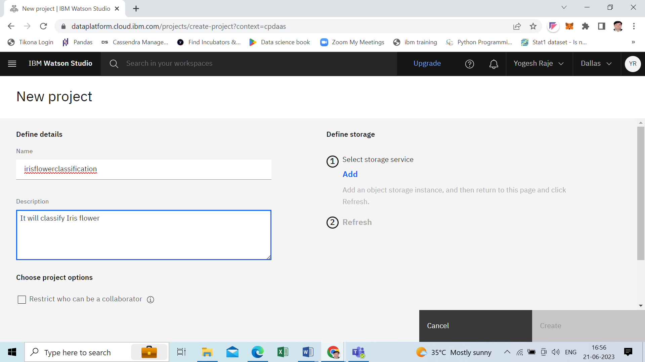

Create cloud storage – click on cloud object storage

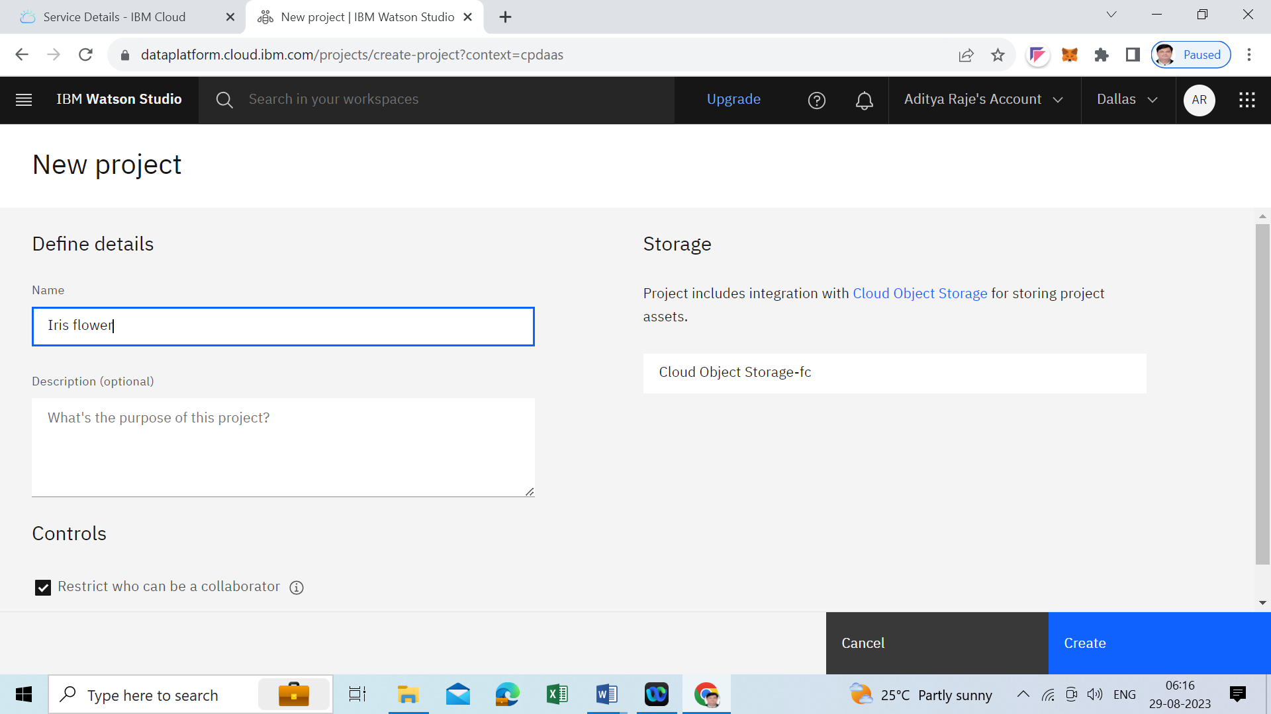

Step5 – Click on **Assets** tab and click on **New asset** button

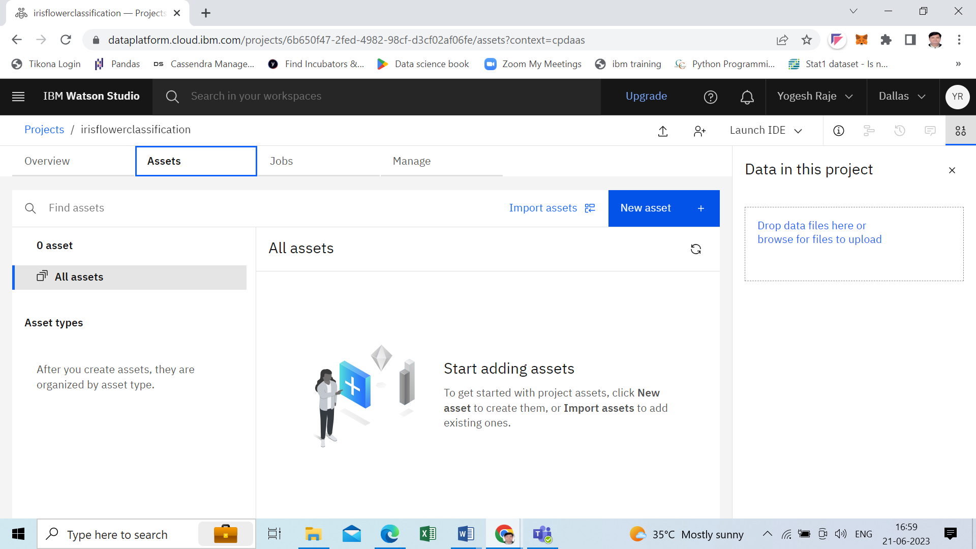

Step5 – select Auto AI

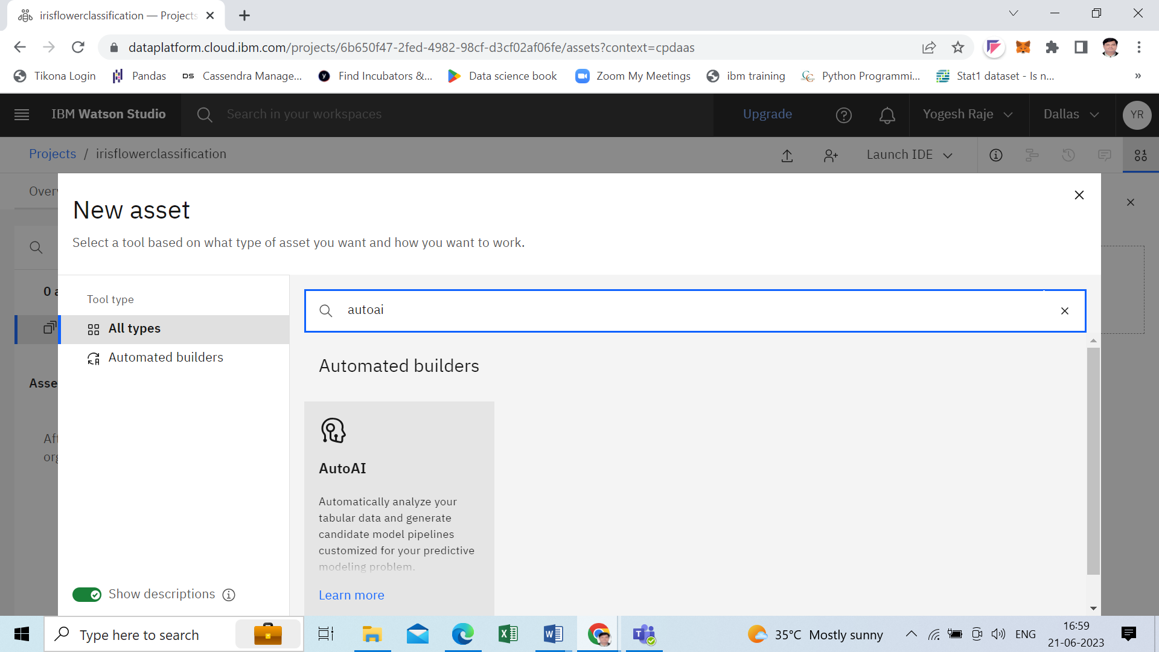

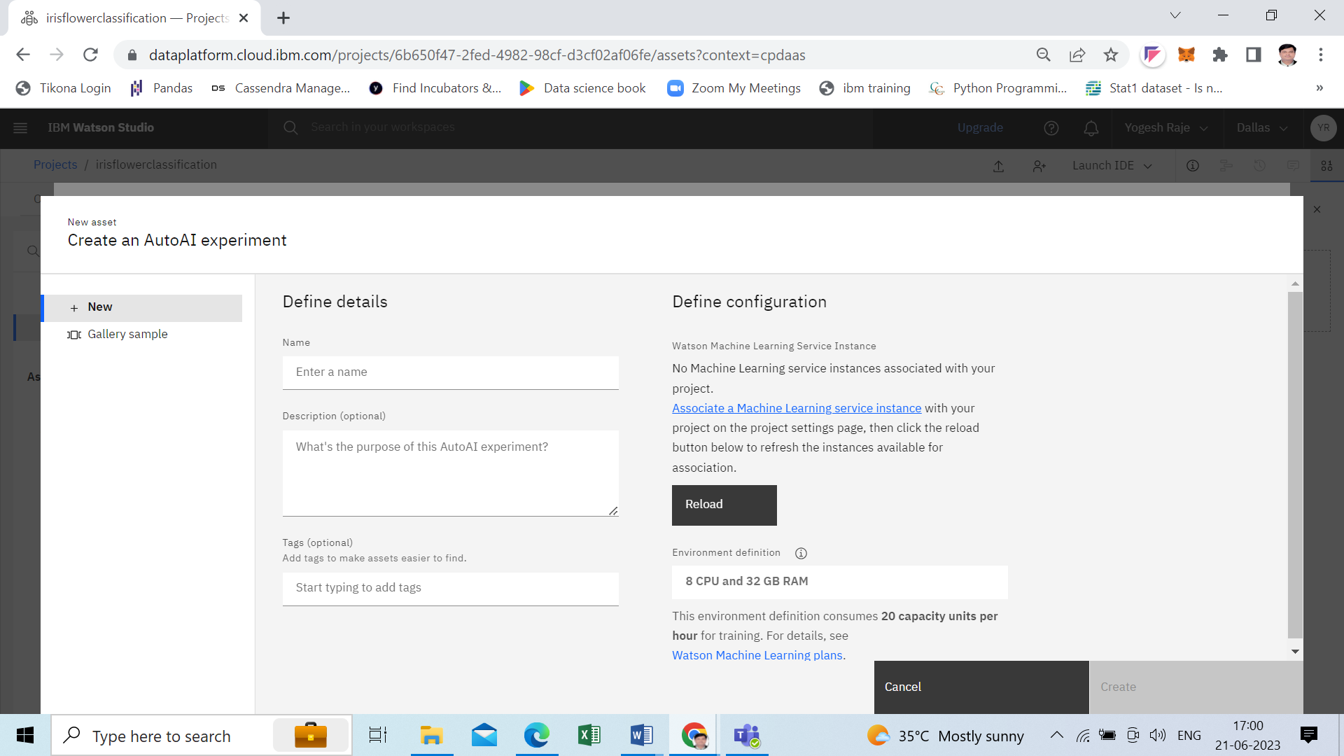

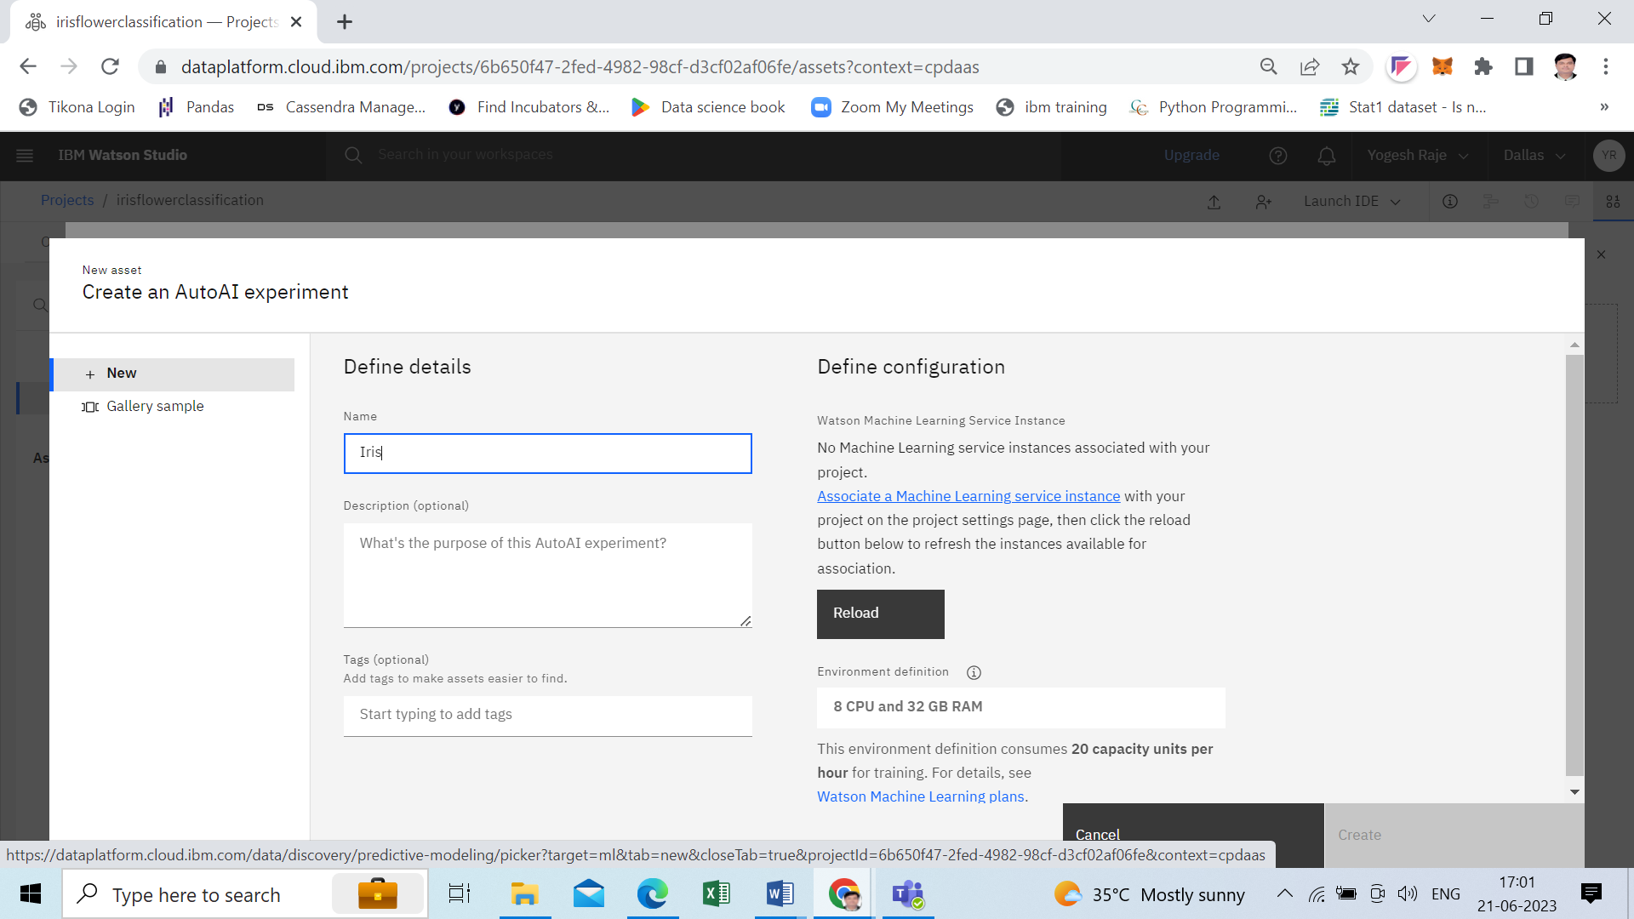

Step6 – select Associate service

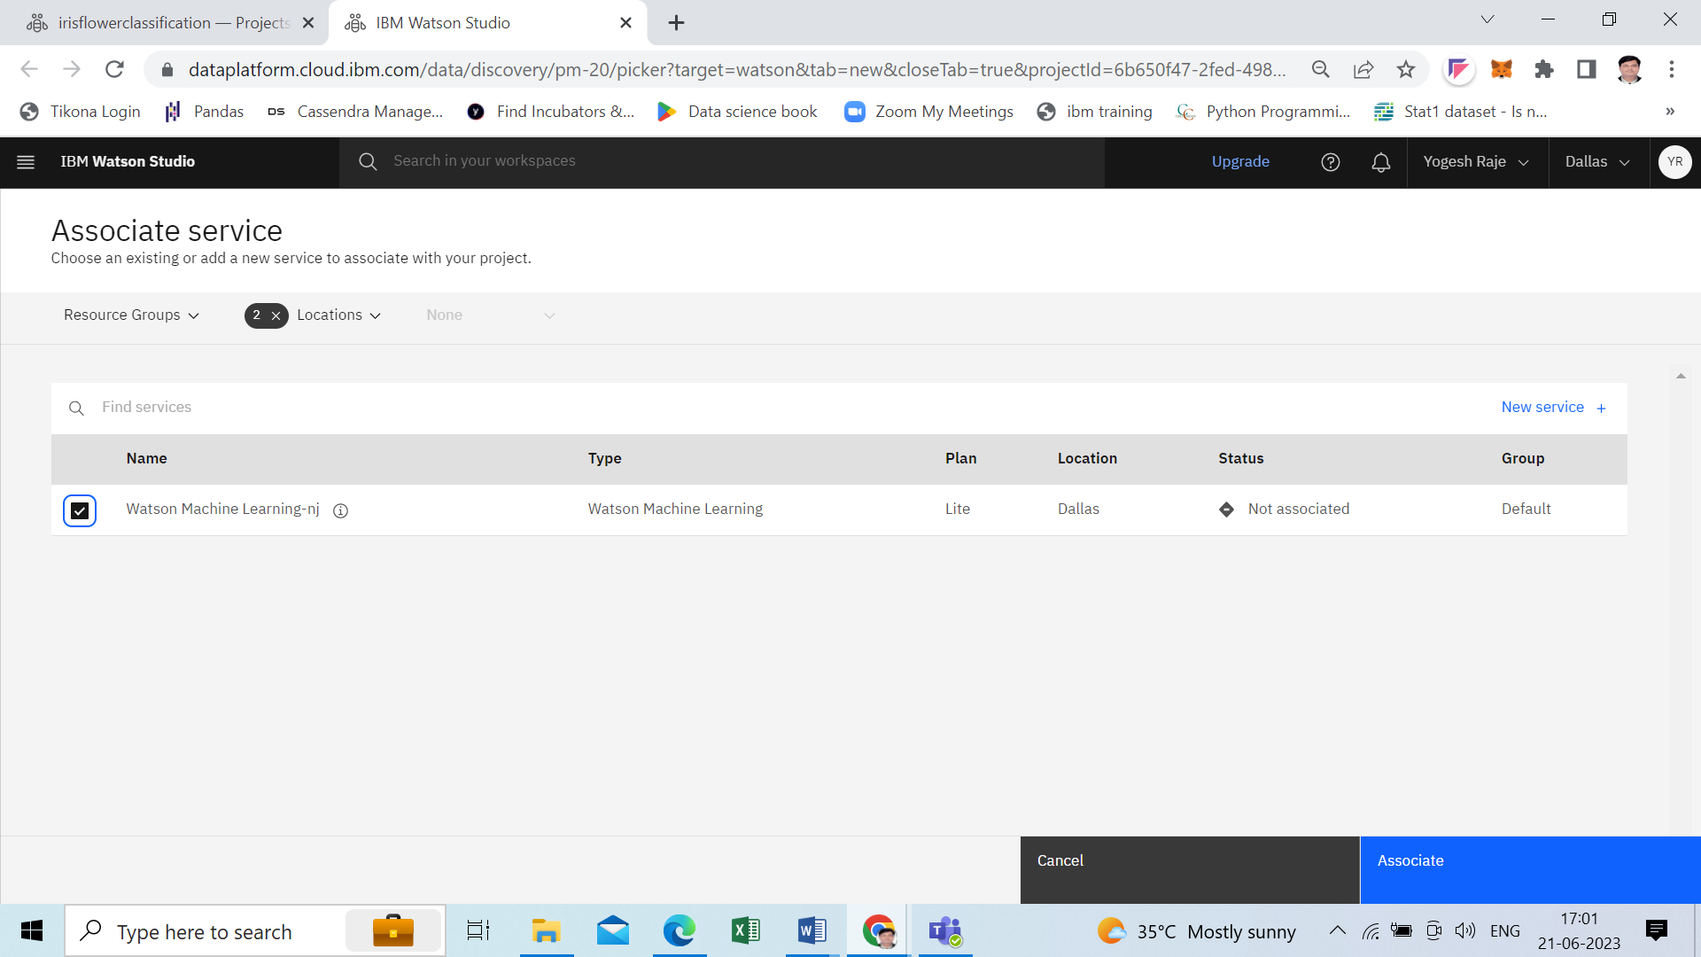

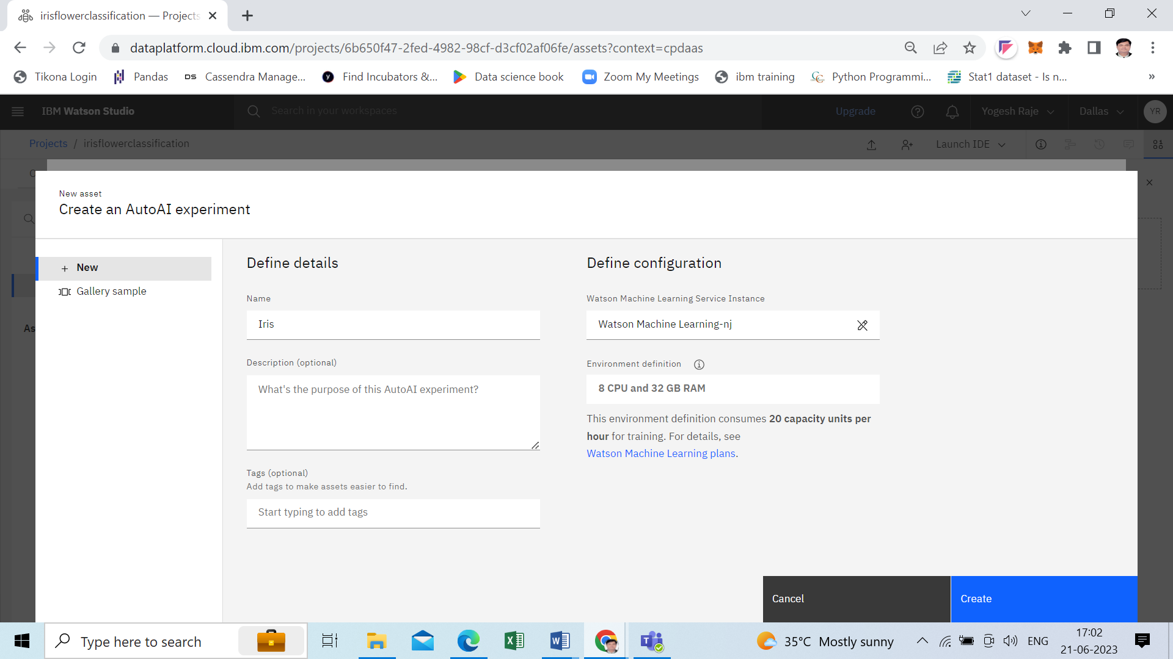

Step7- Upload your dataset,e.g. Iris.csv . Click on **No** button for Create a time series analysis

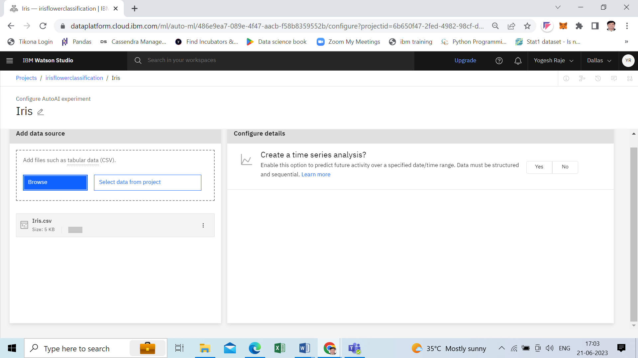

Step8- under what do you want to predict, select your **target label** and click on **Run Experiment**

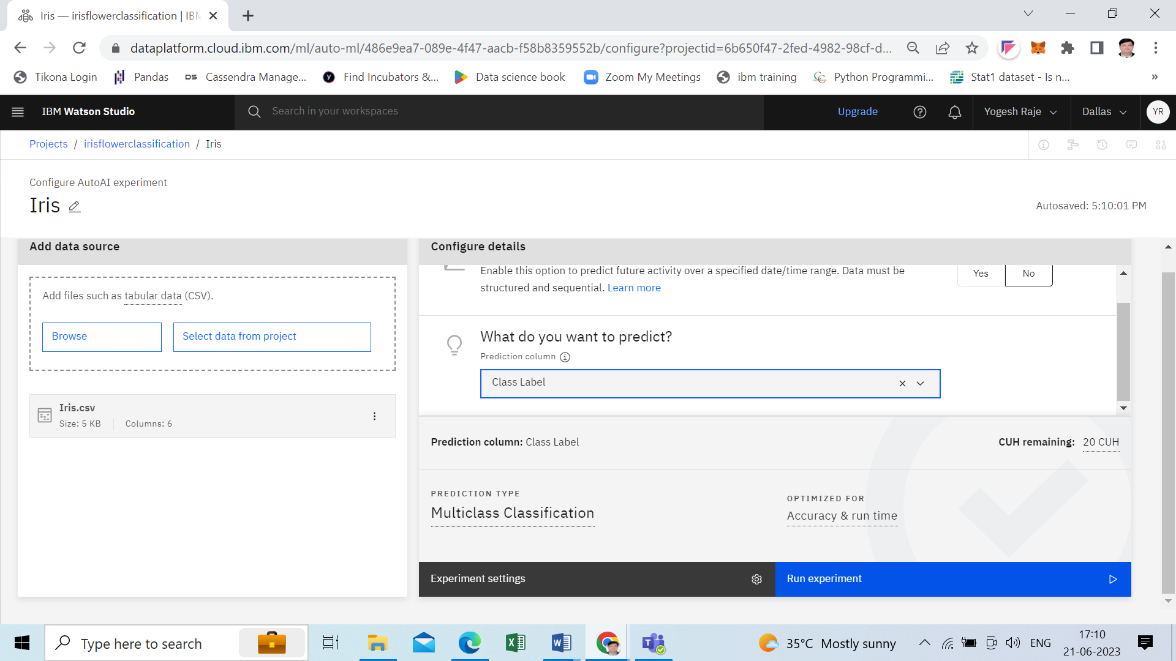

Step9 – View the result of your experiment

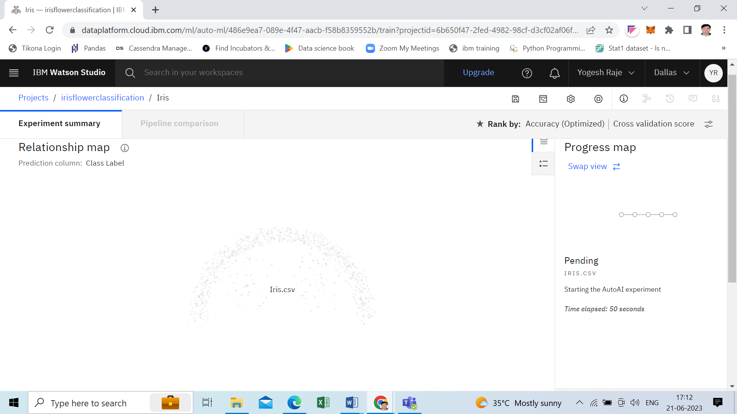

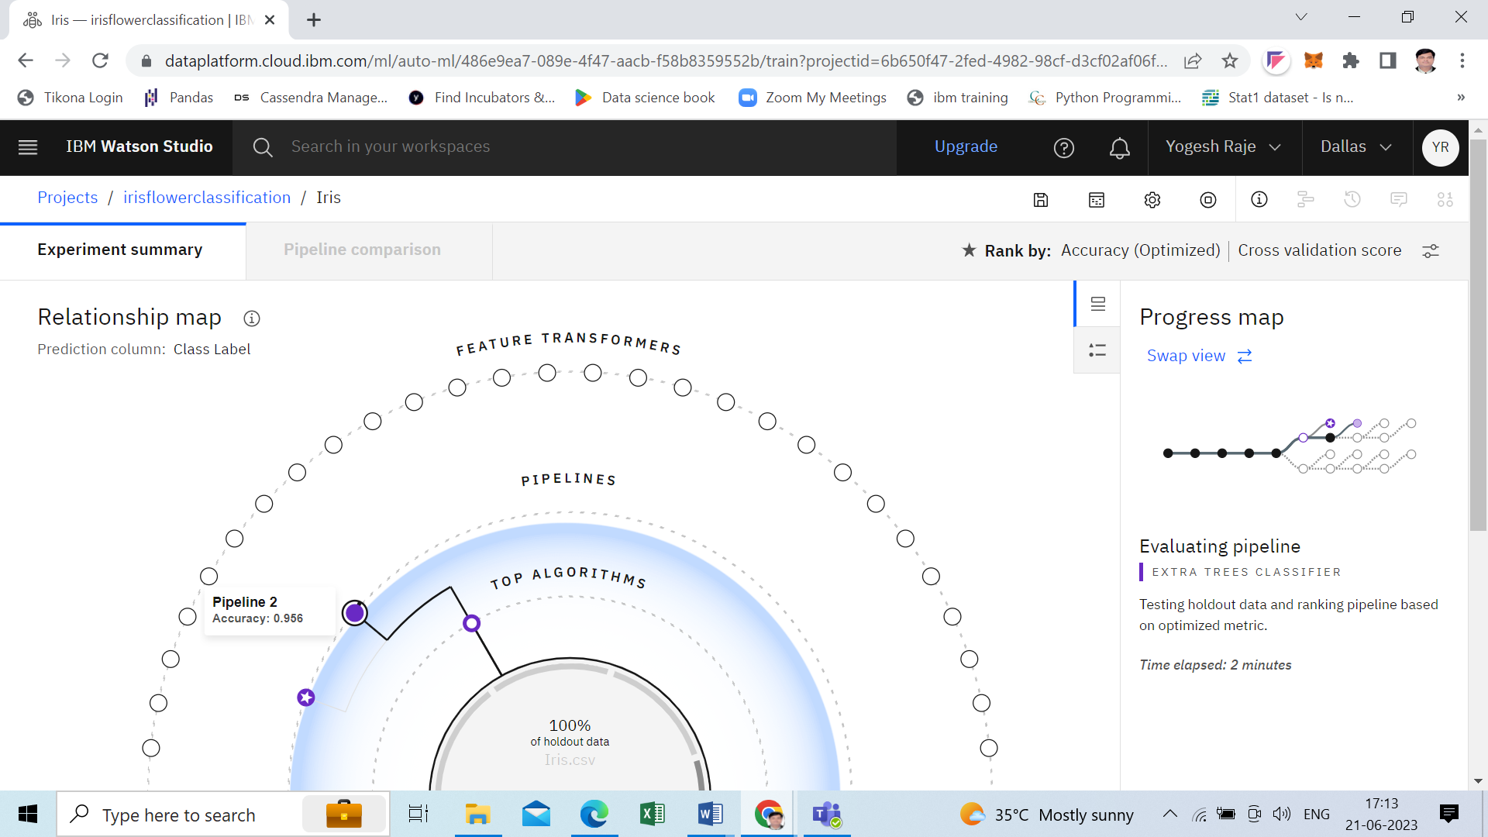

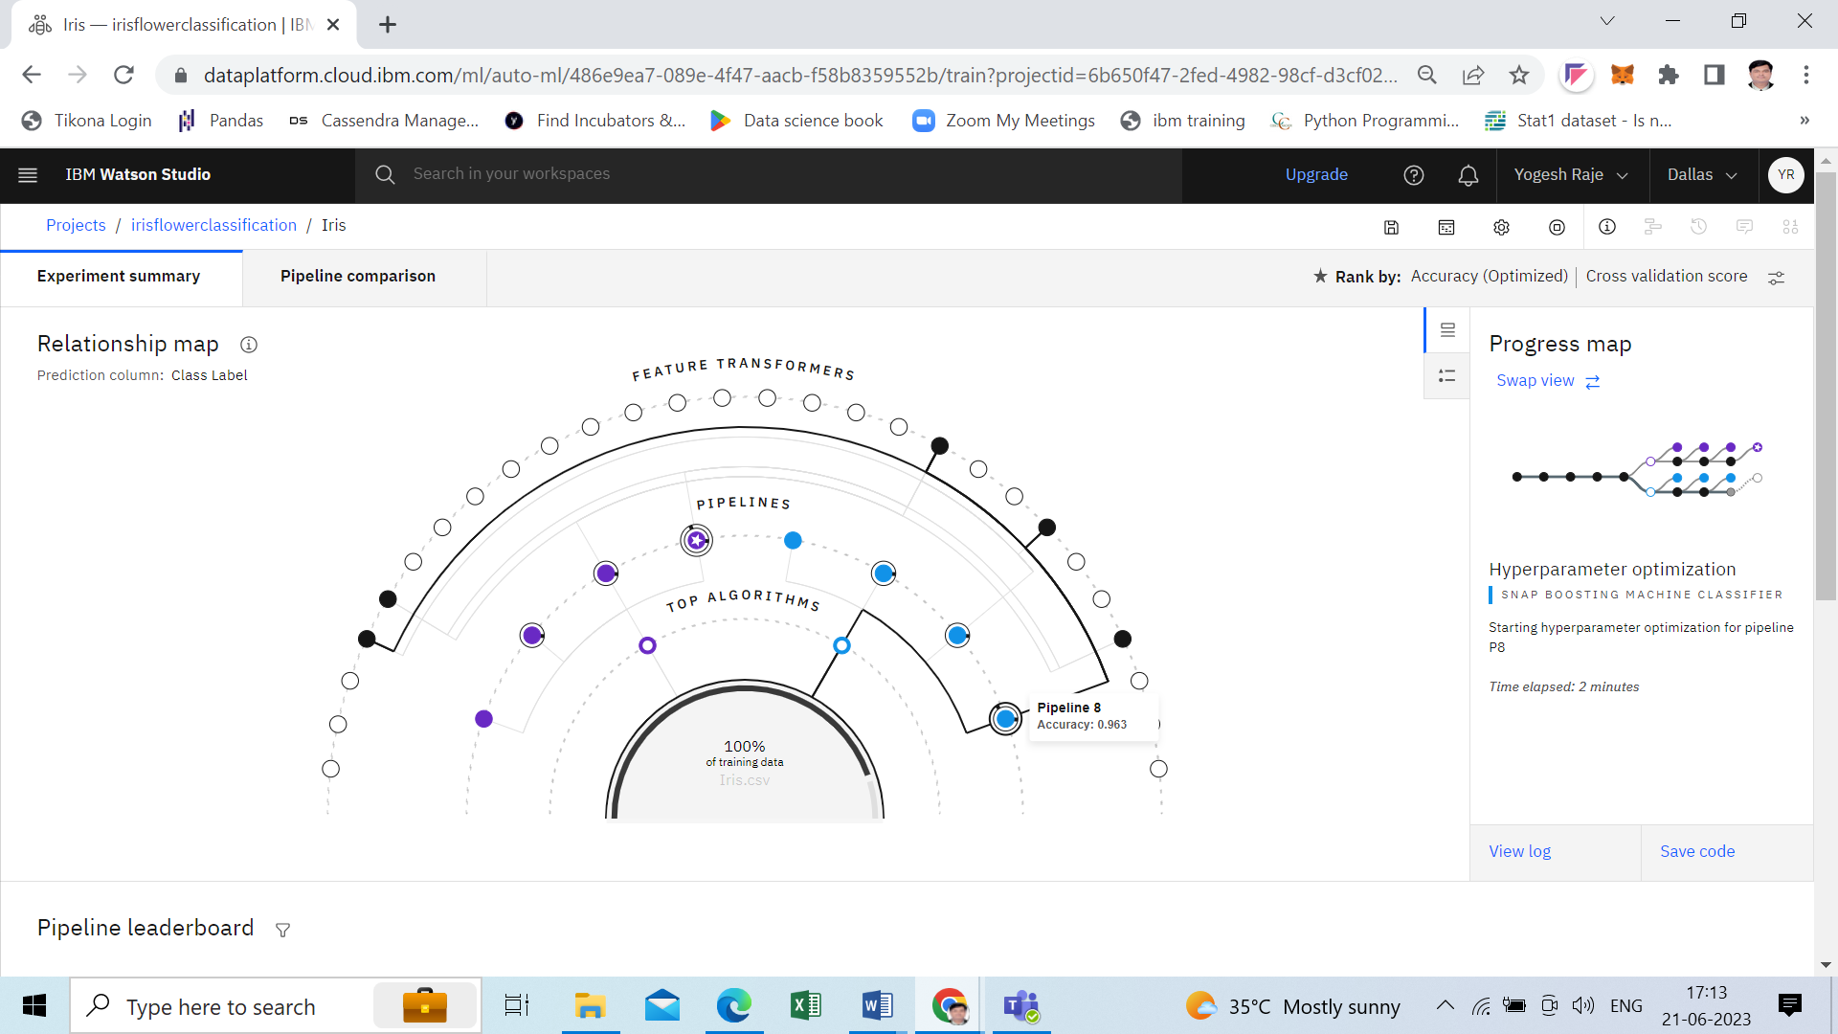

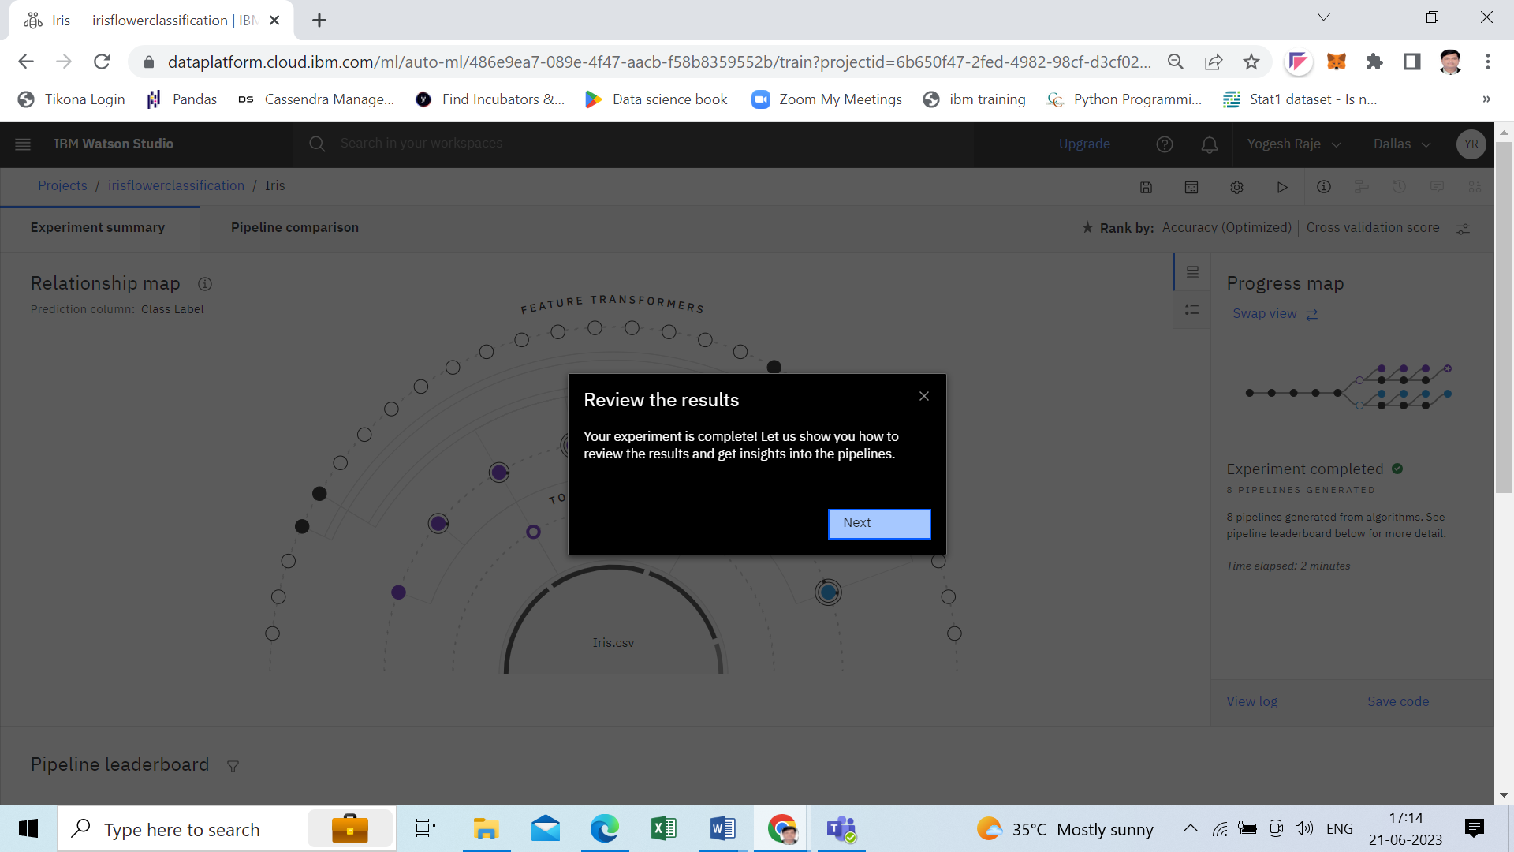

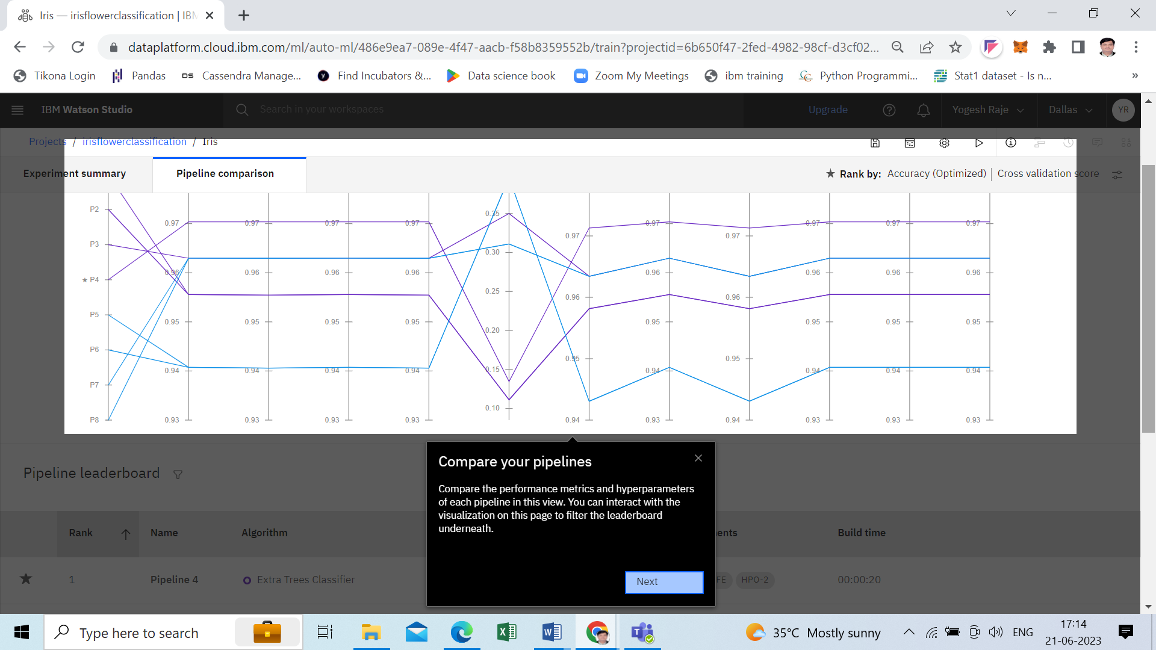

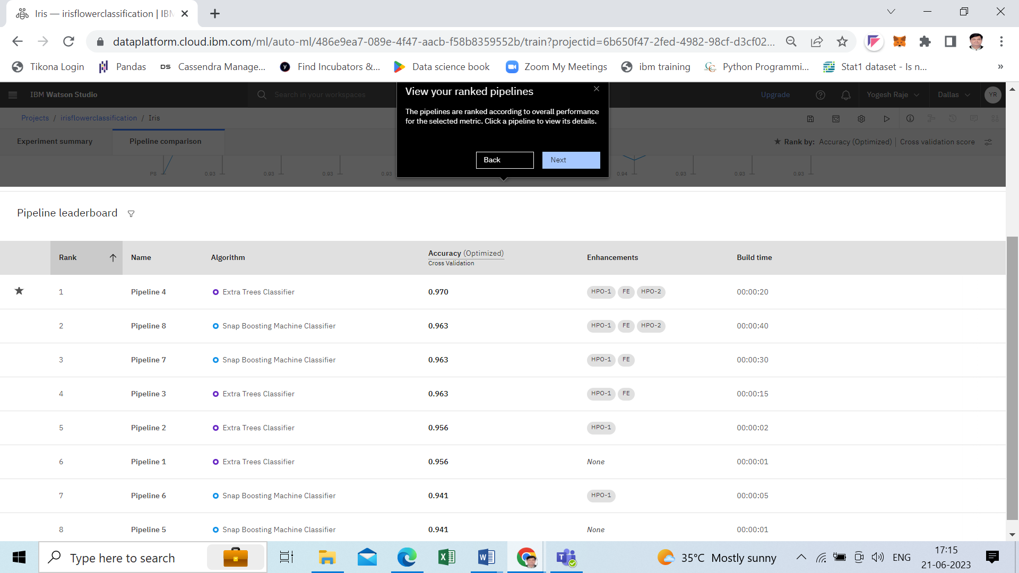

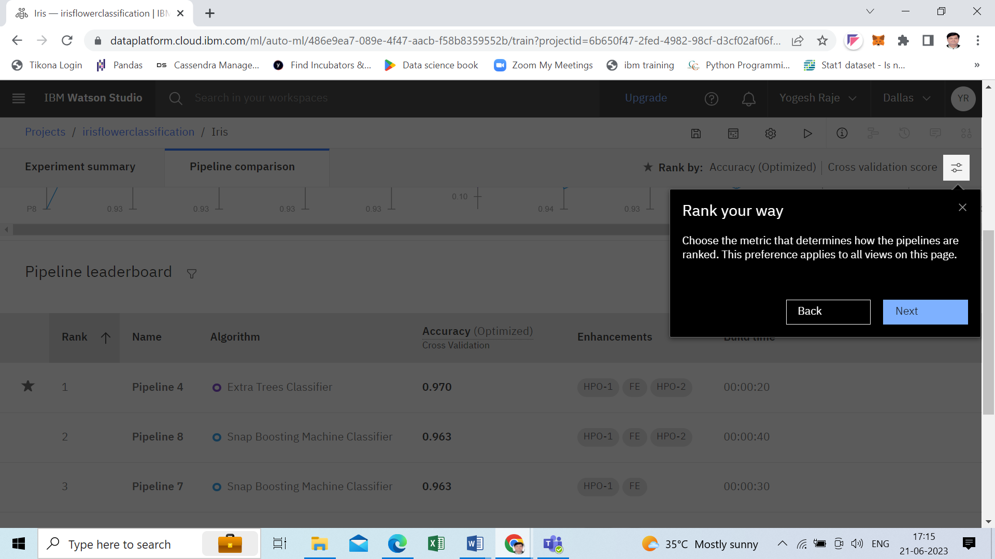

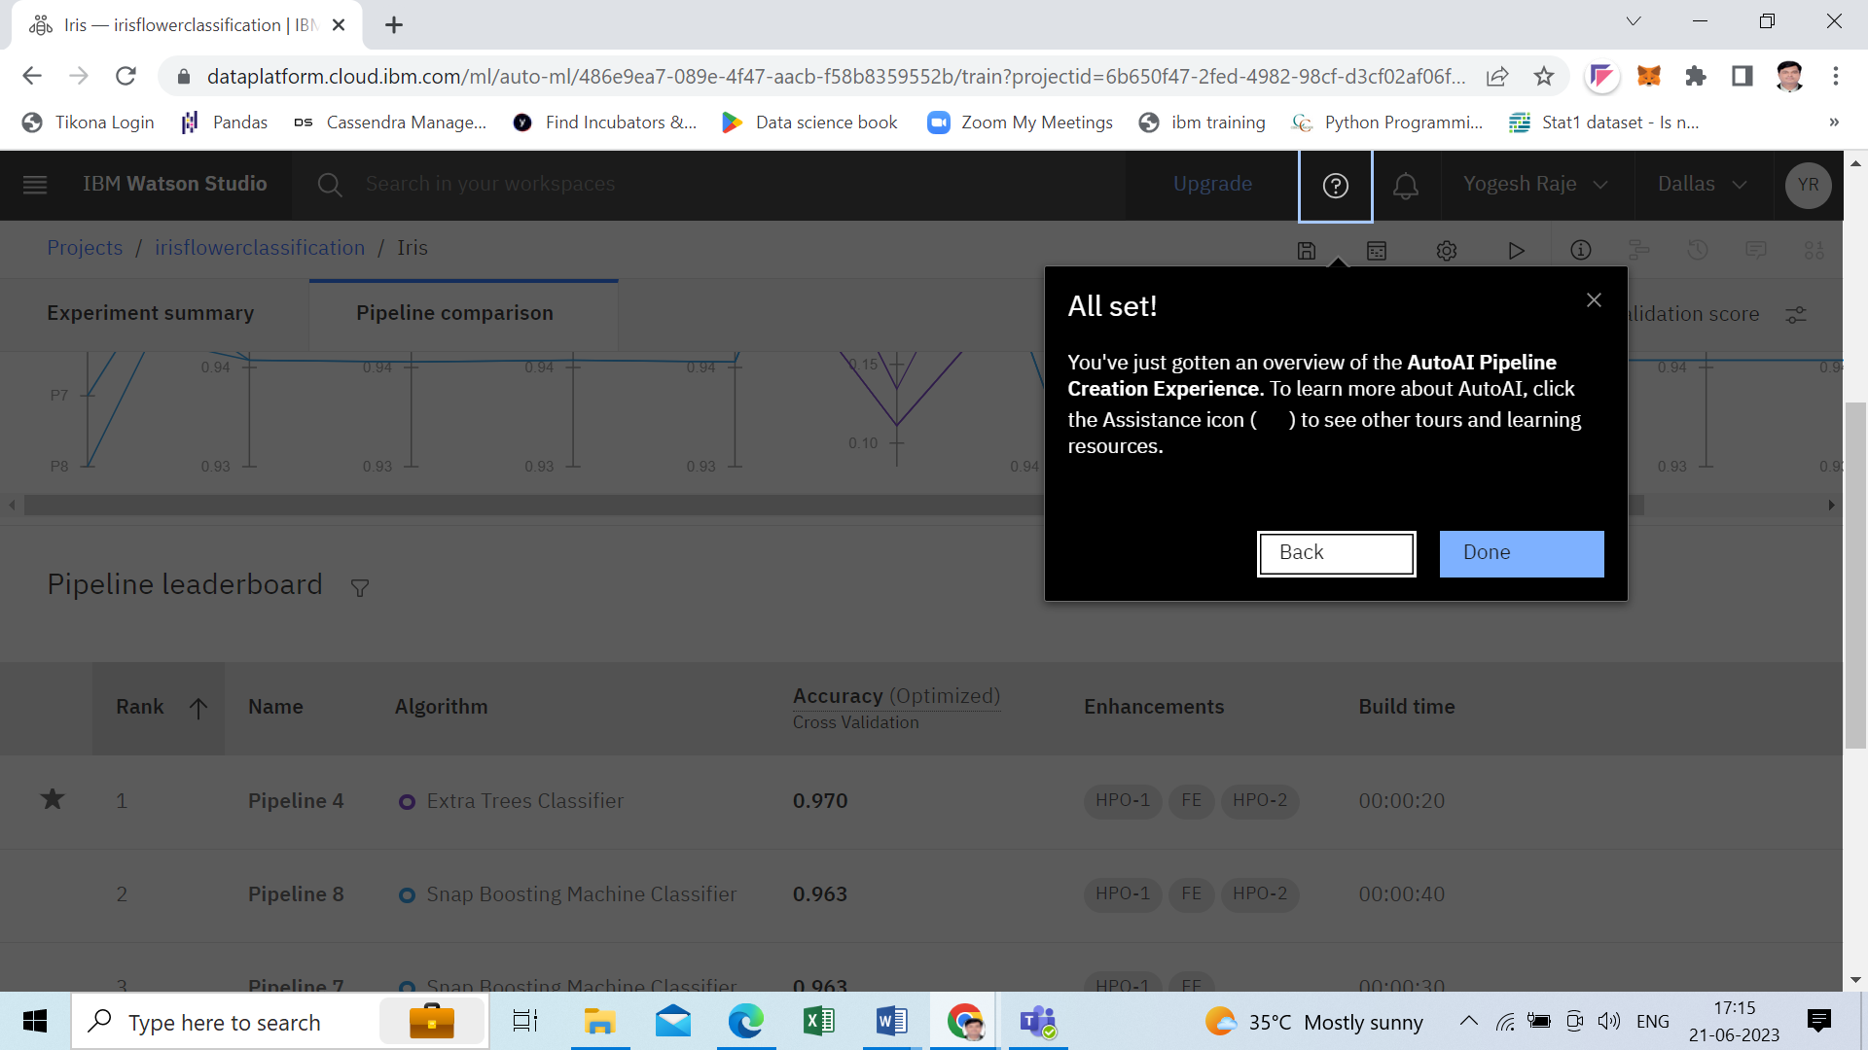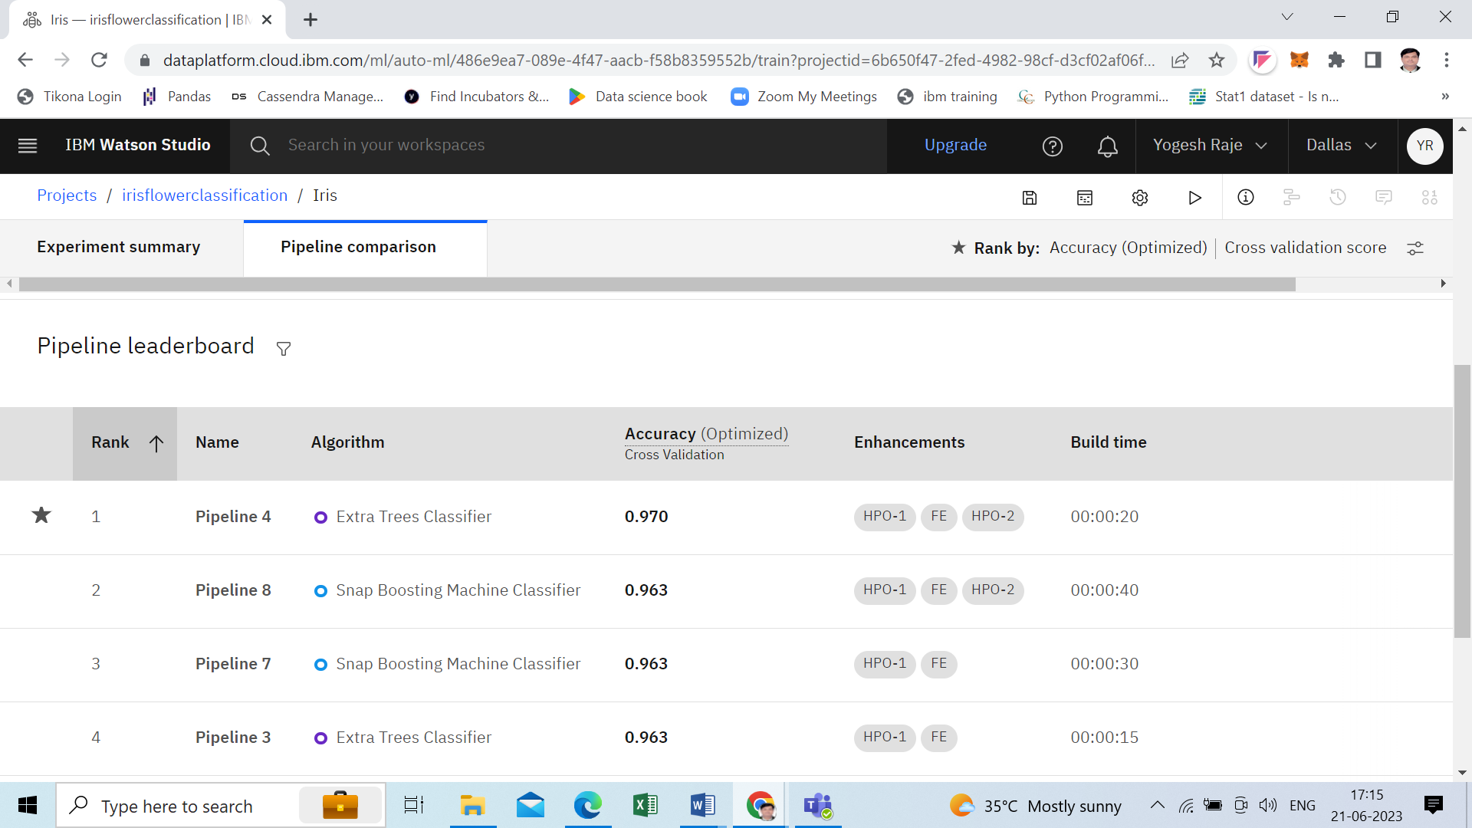

Step10 – Save your model

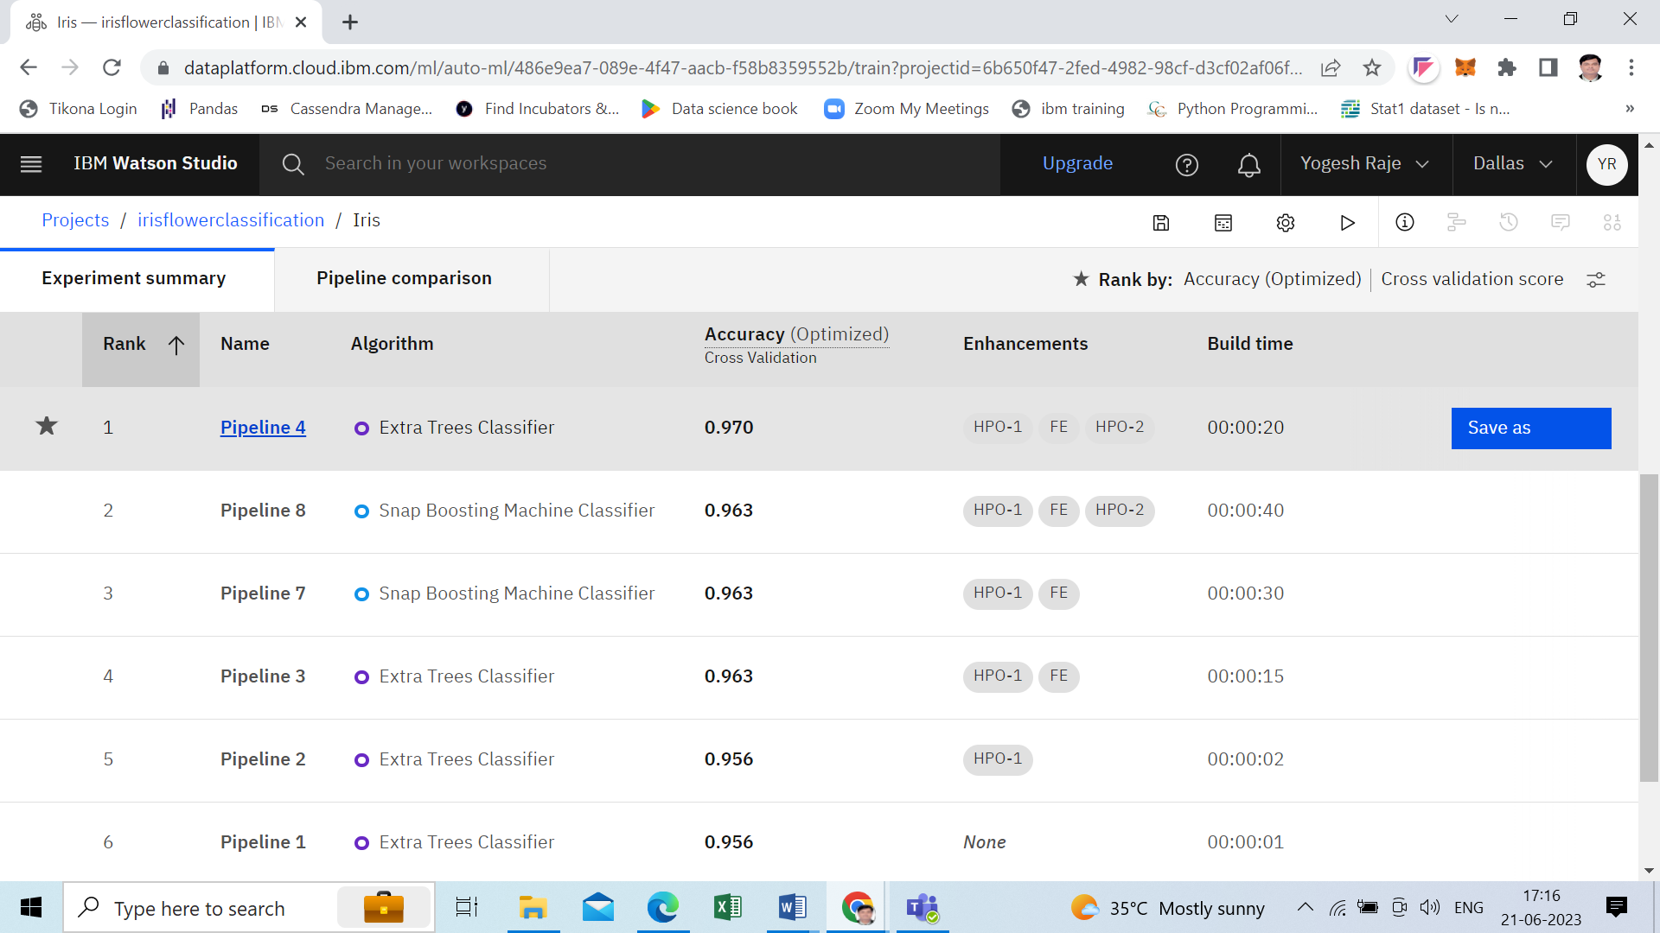

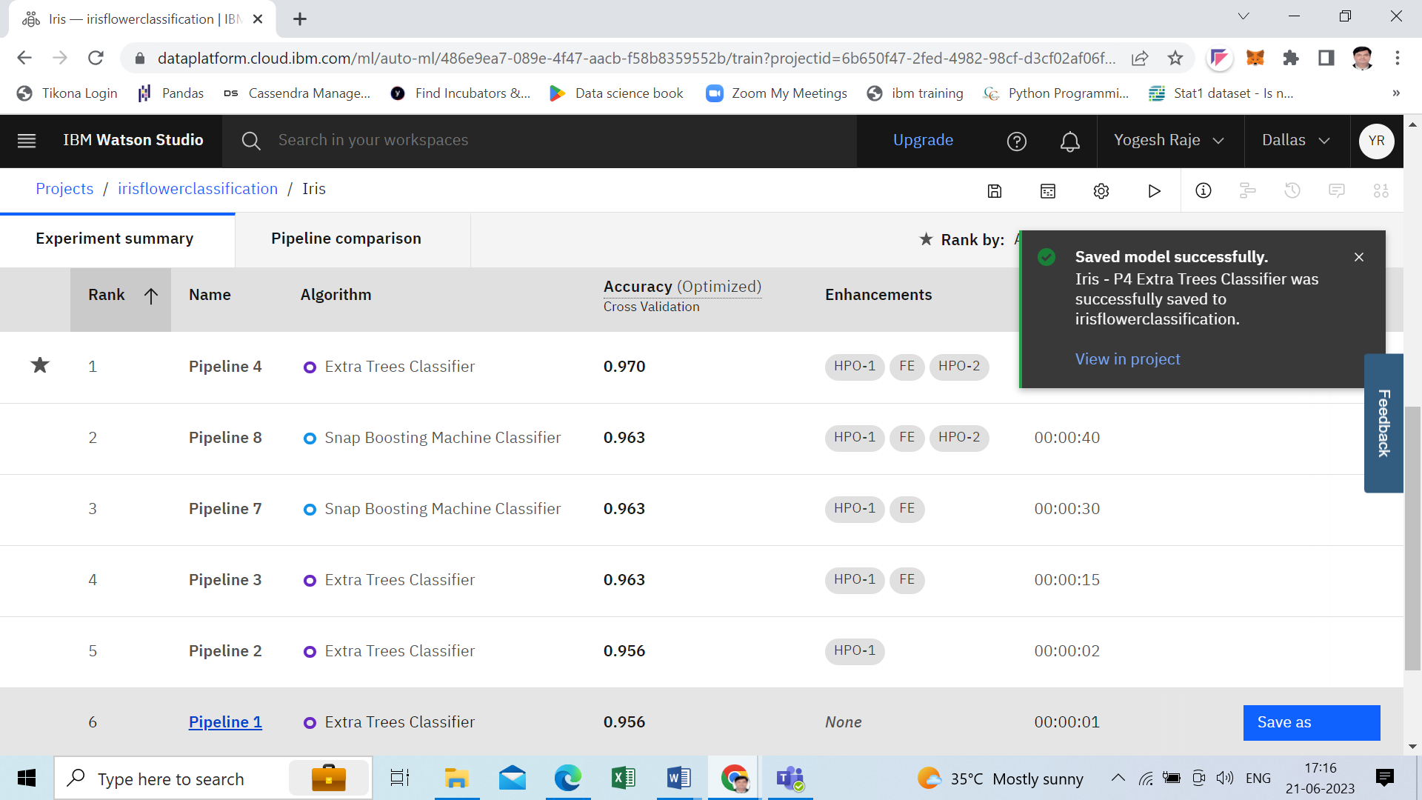

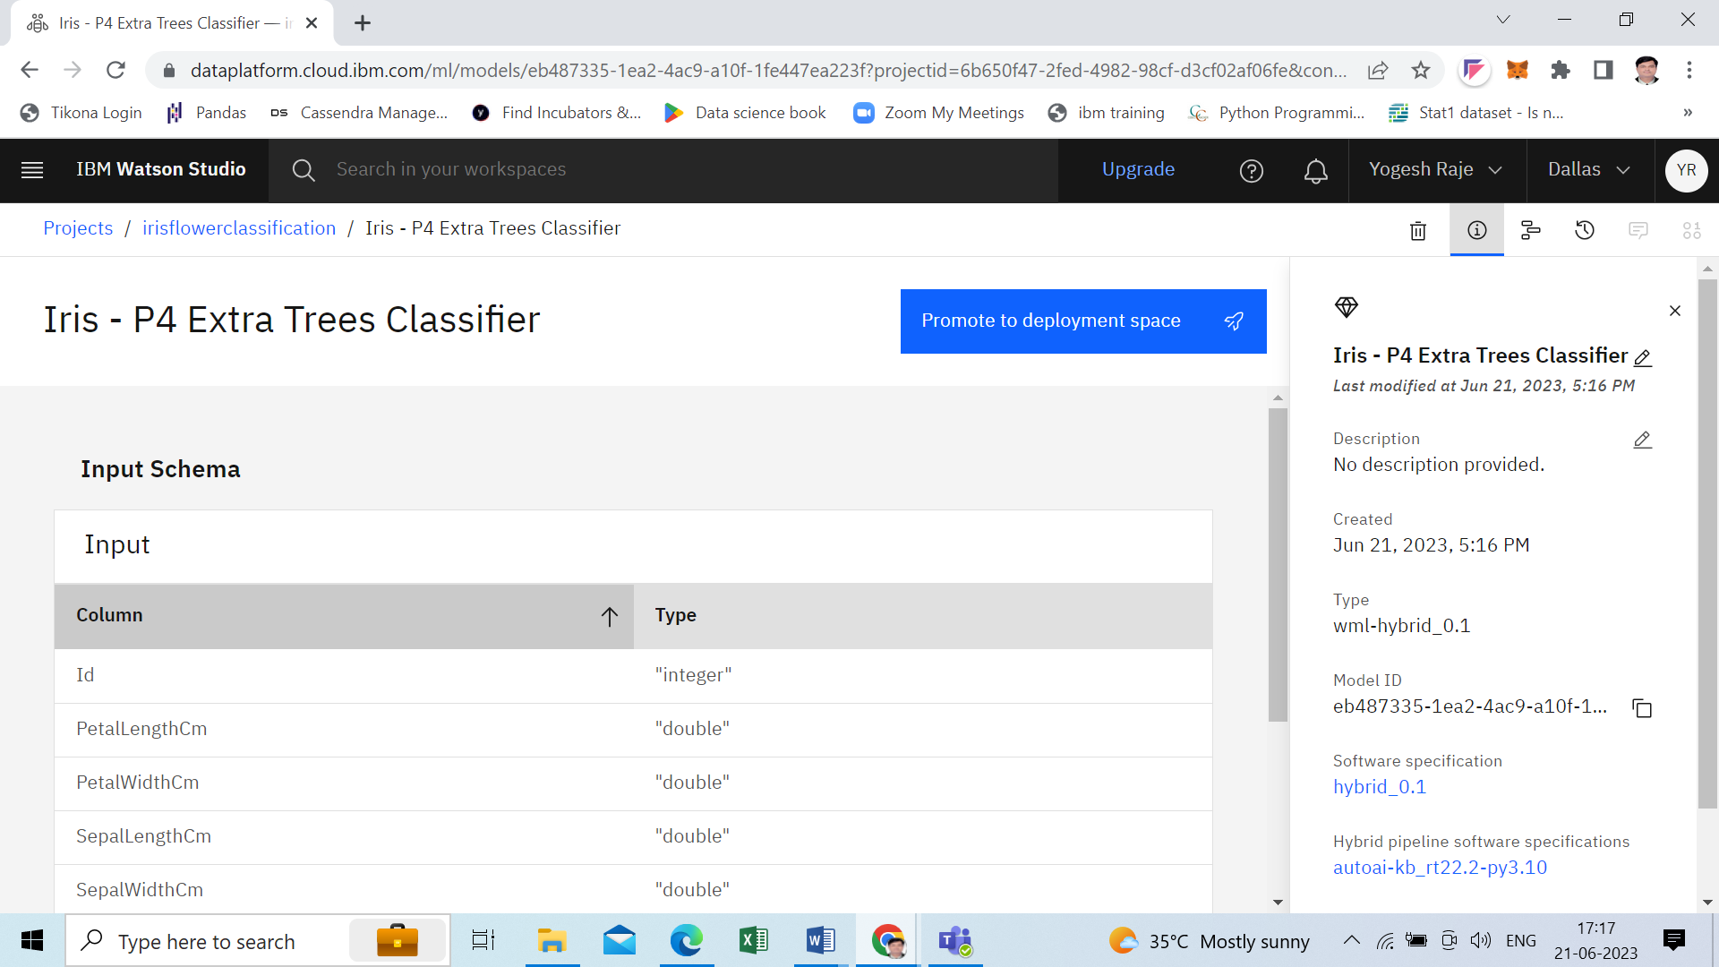

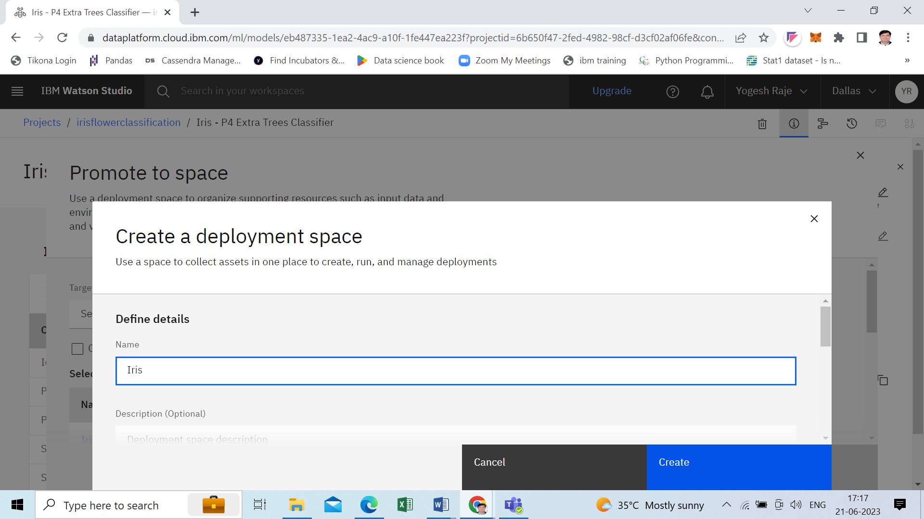

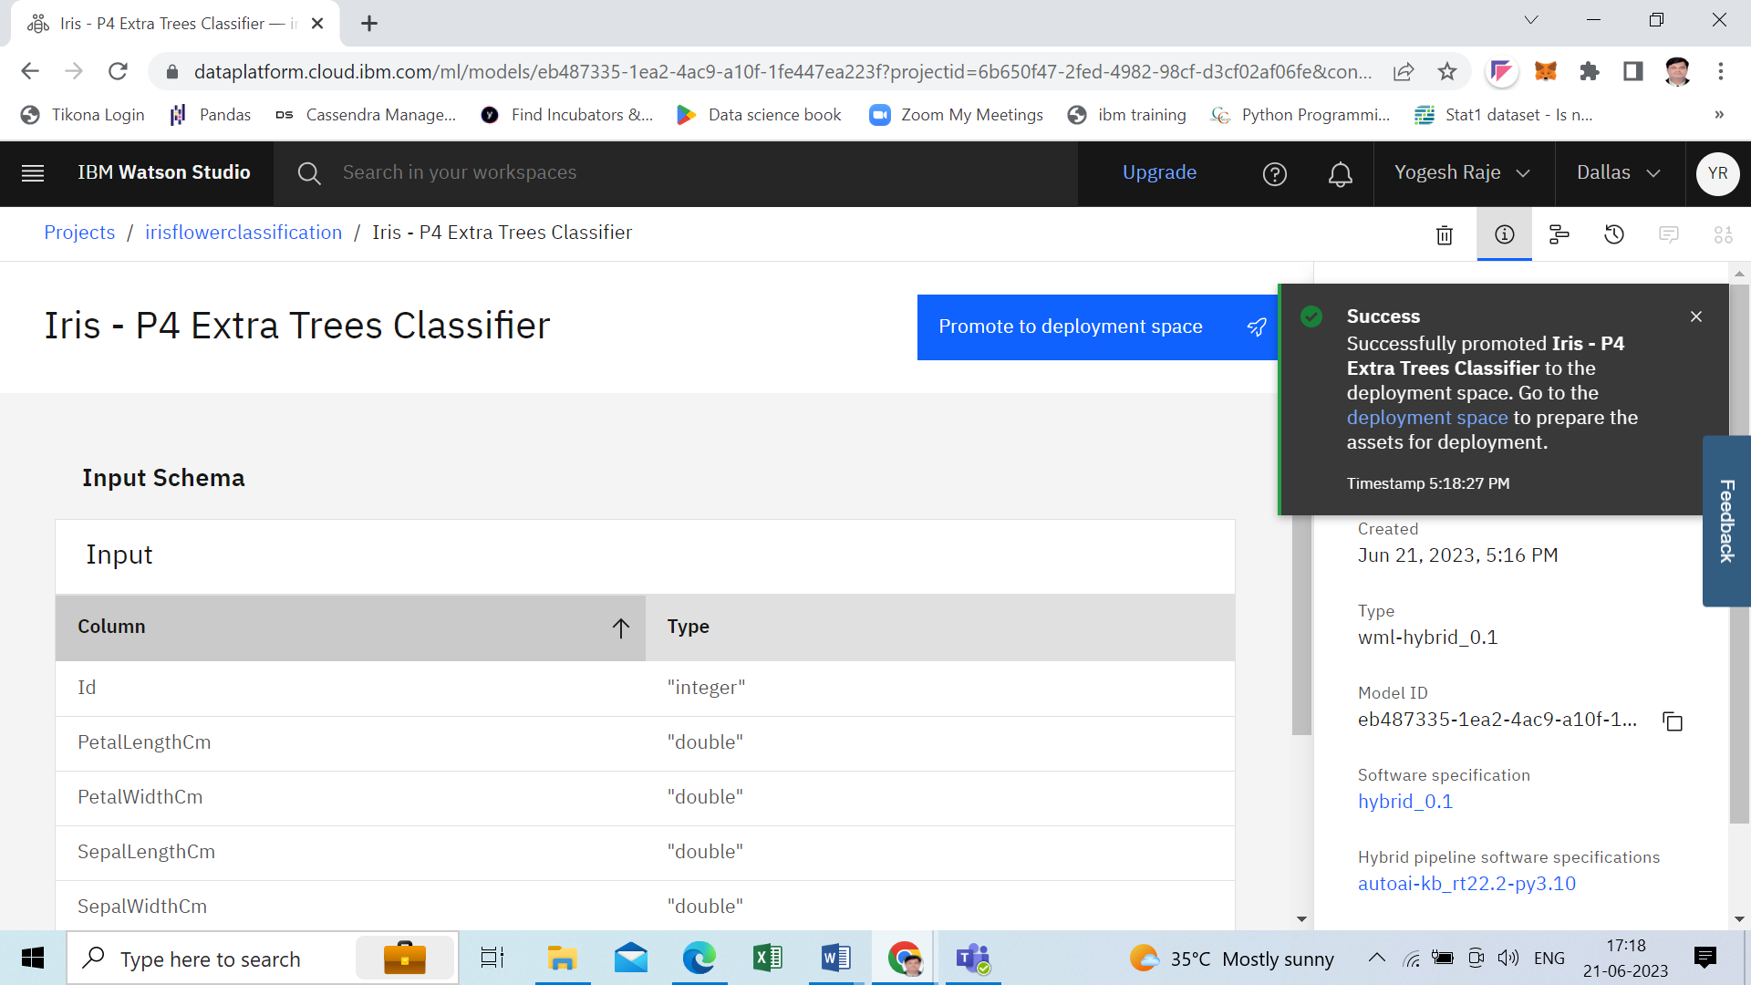

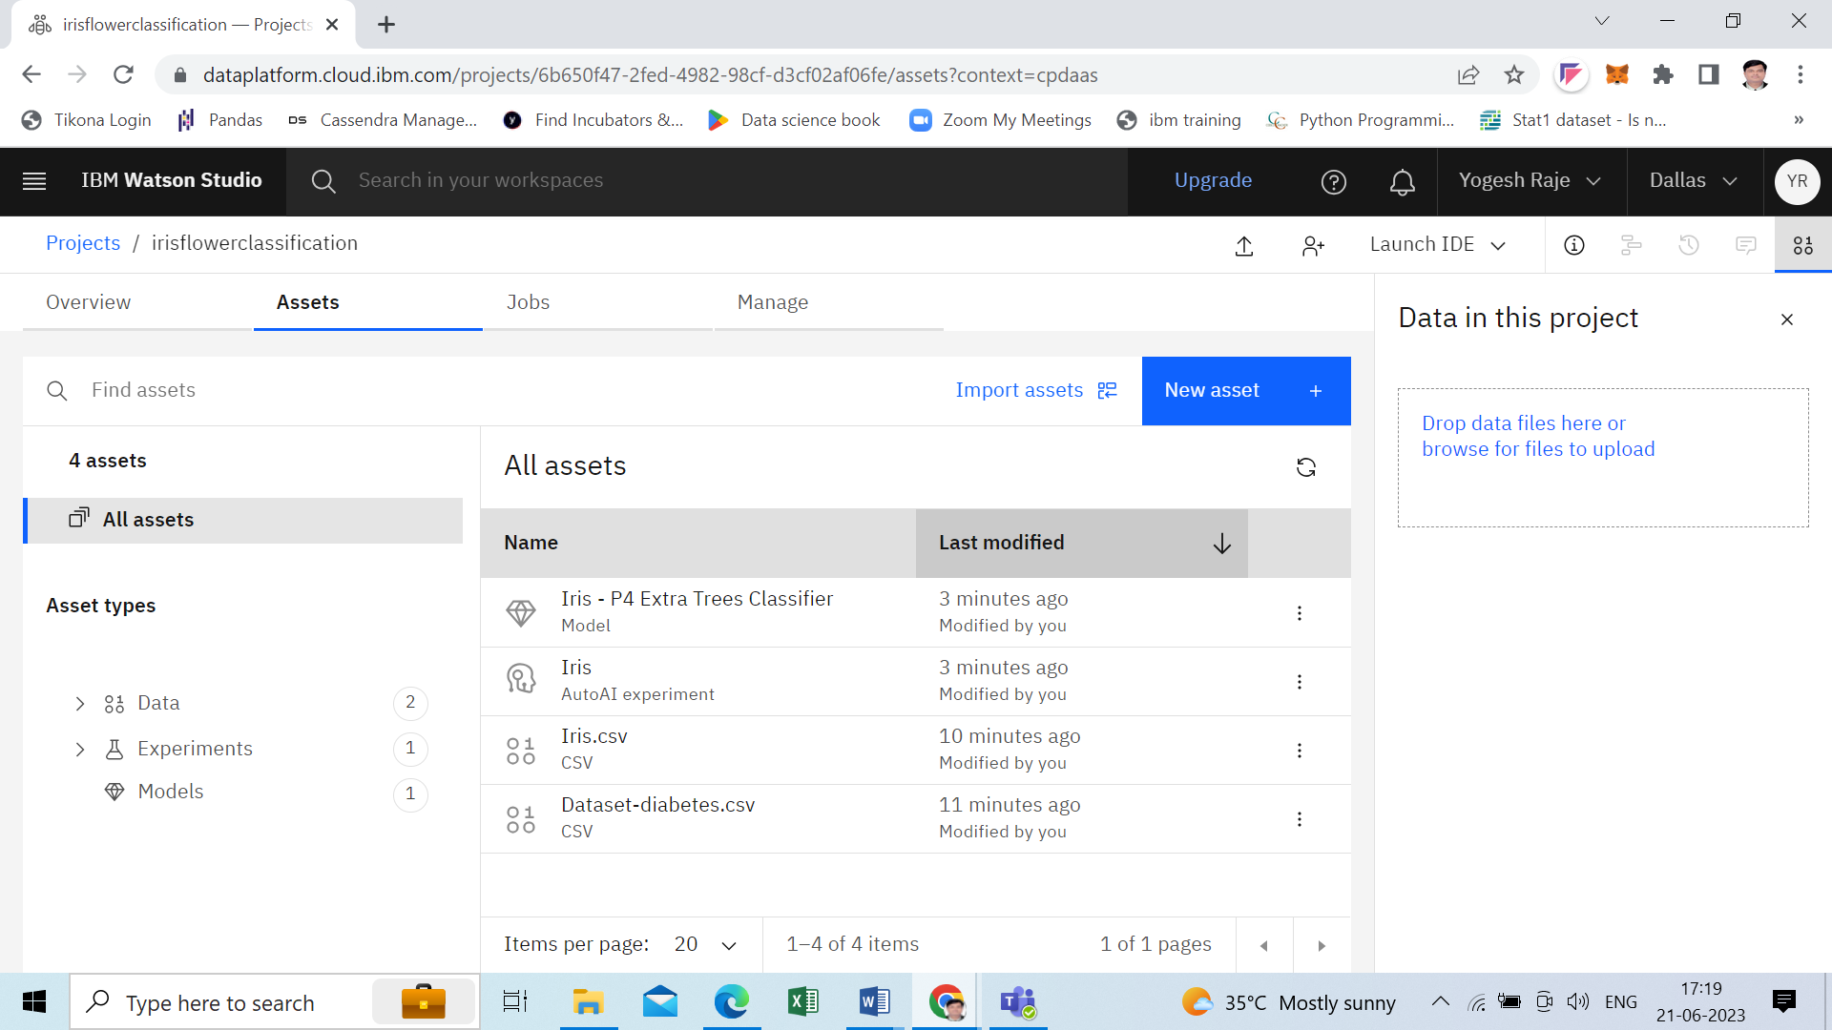

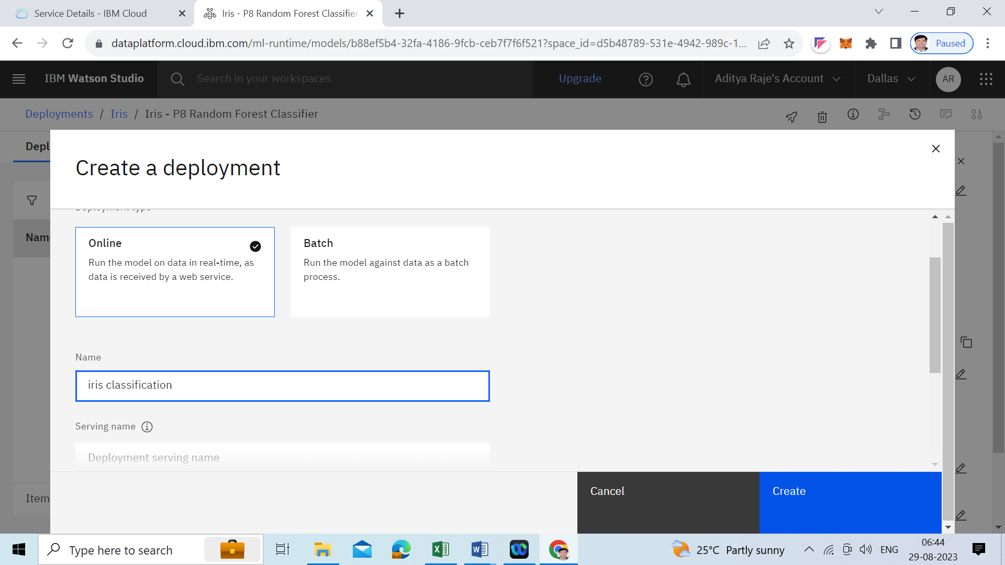

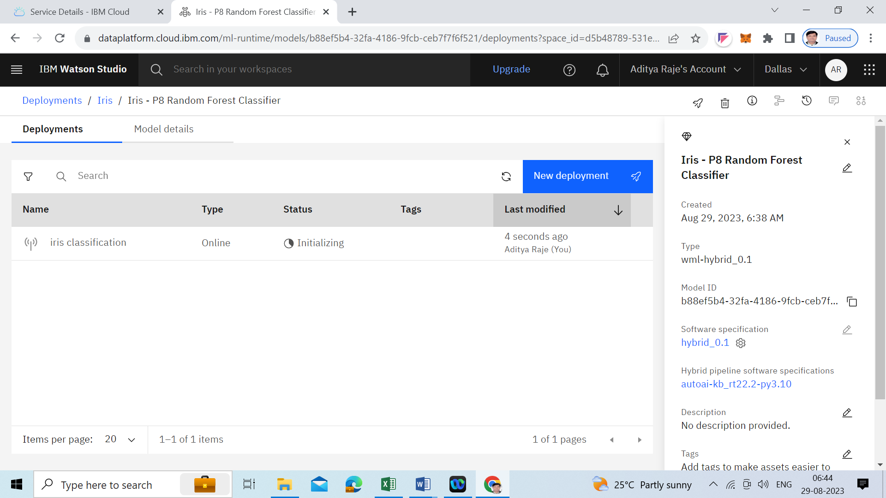

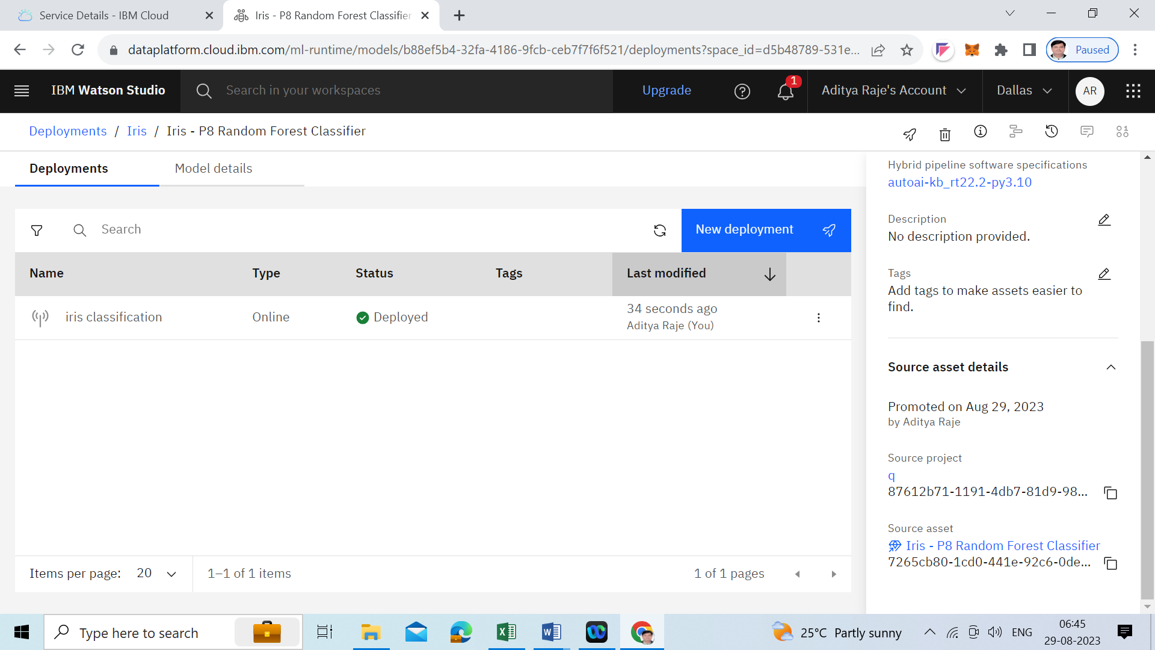

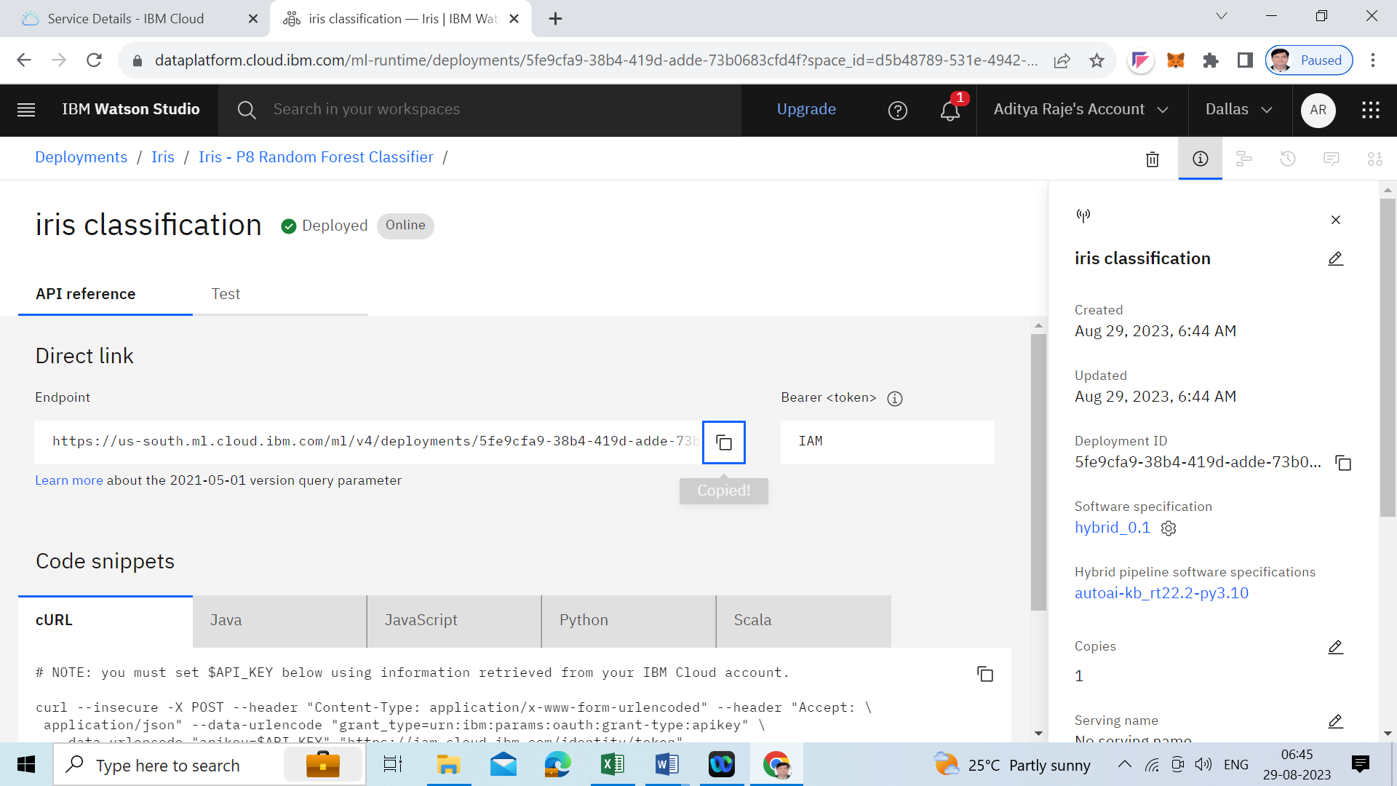

Test your model

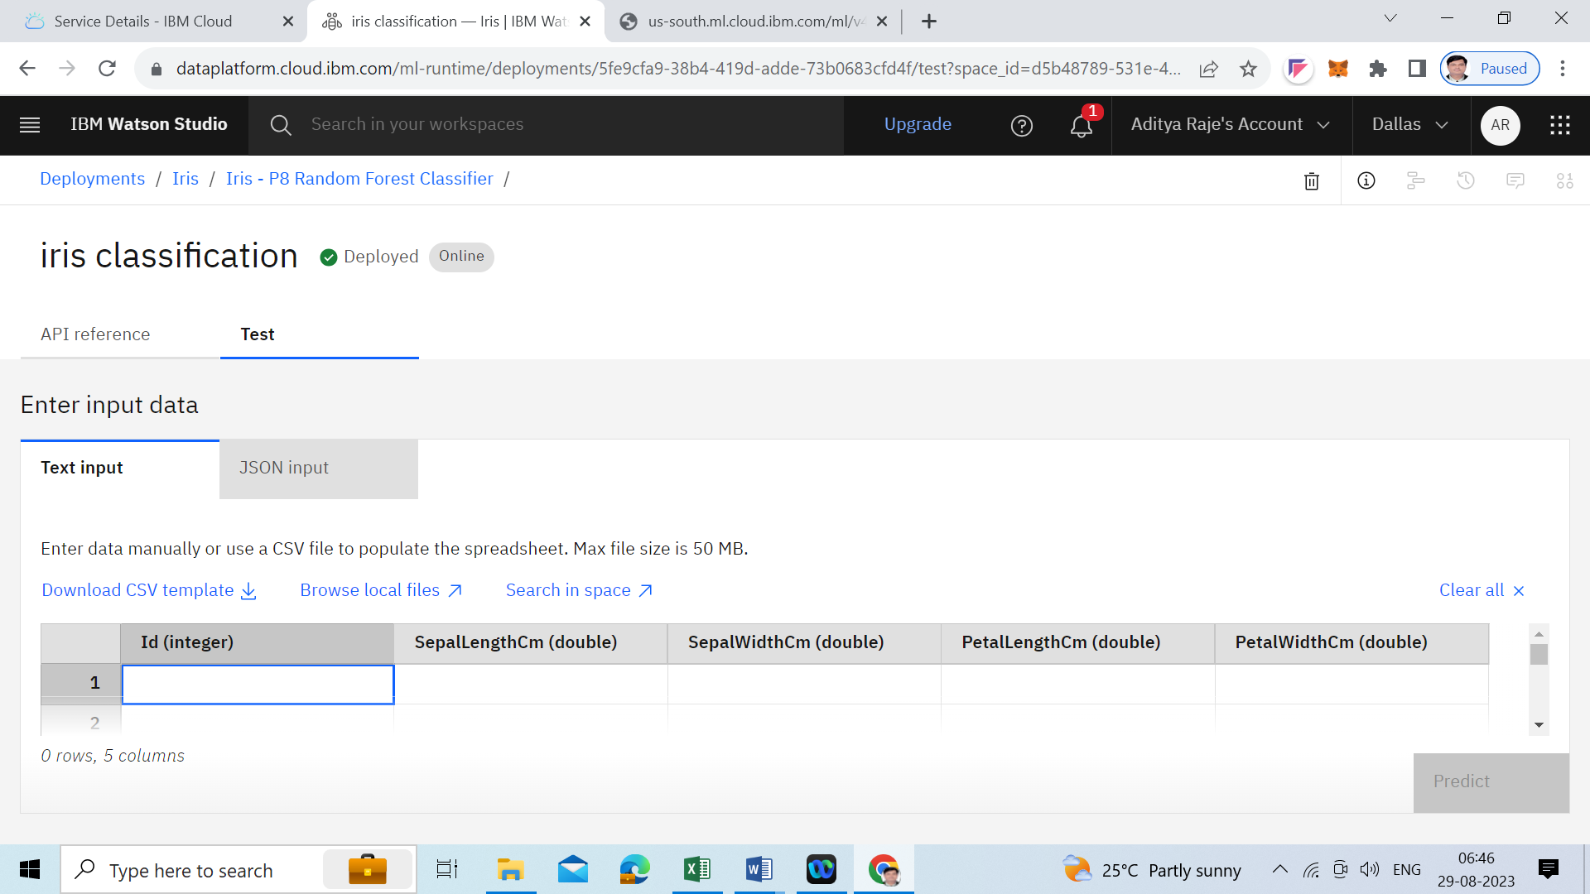

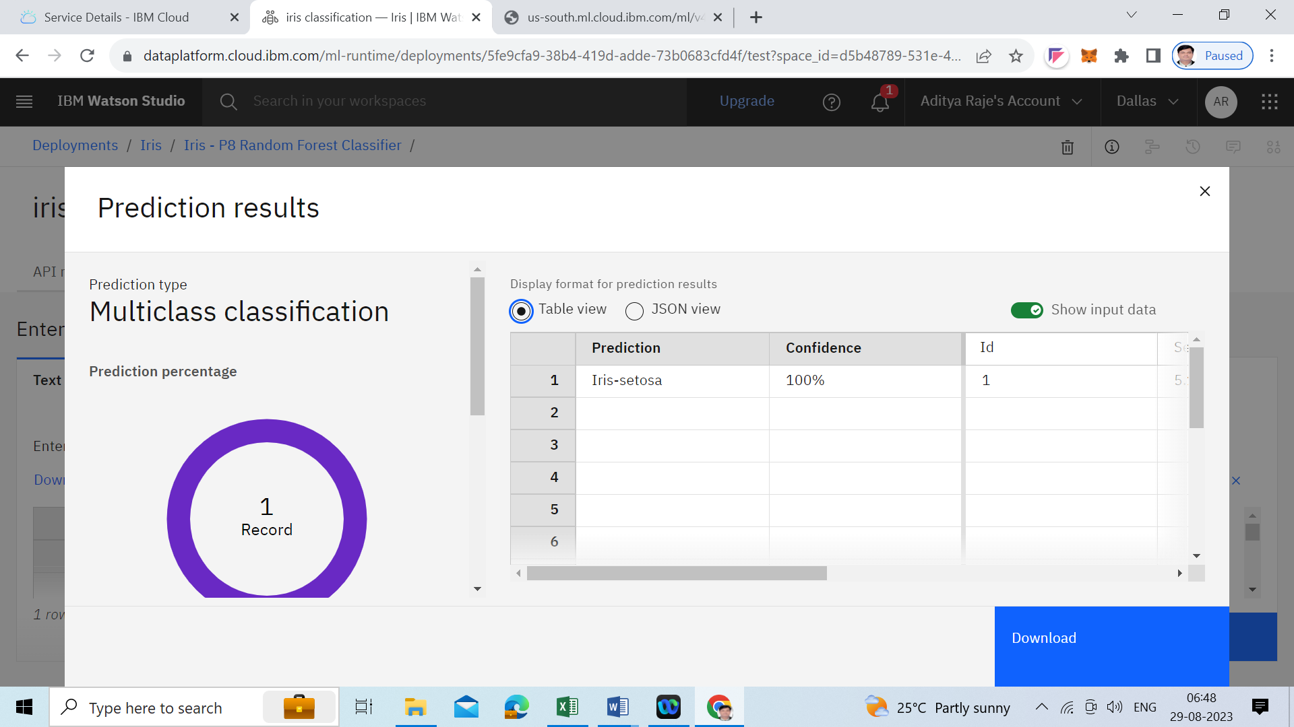

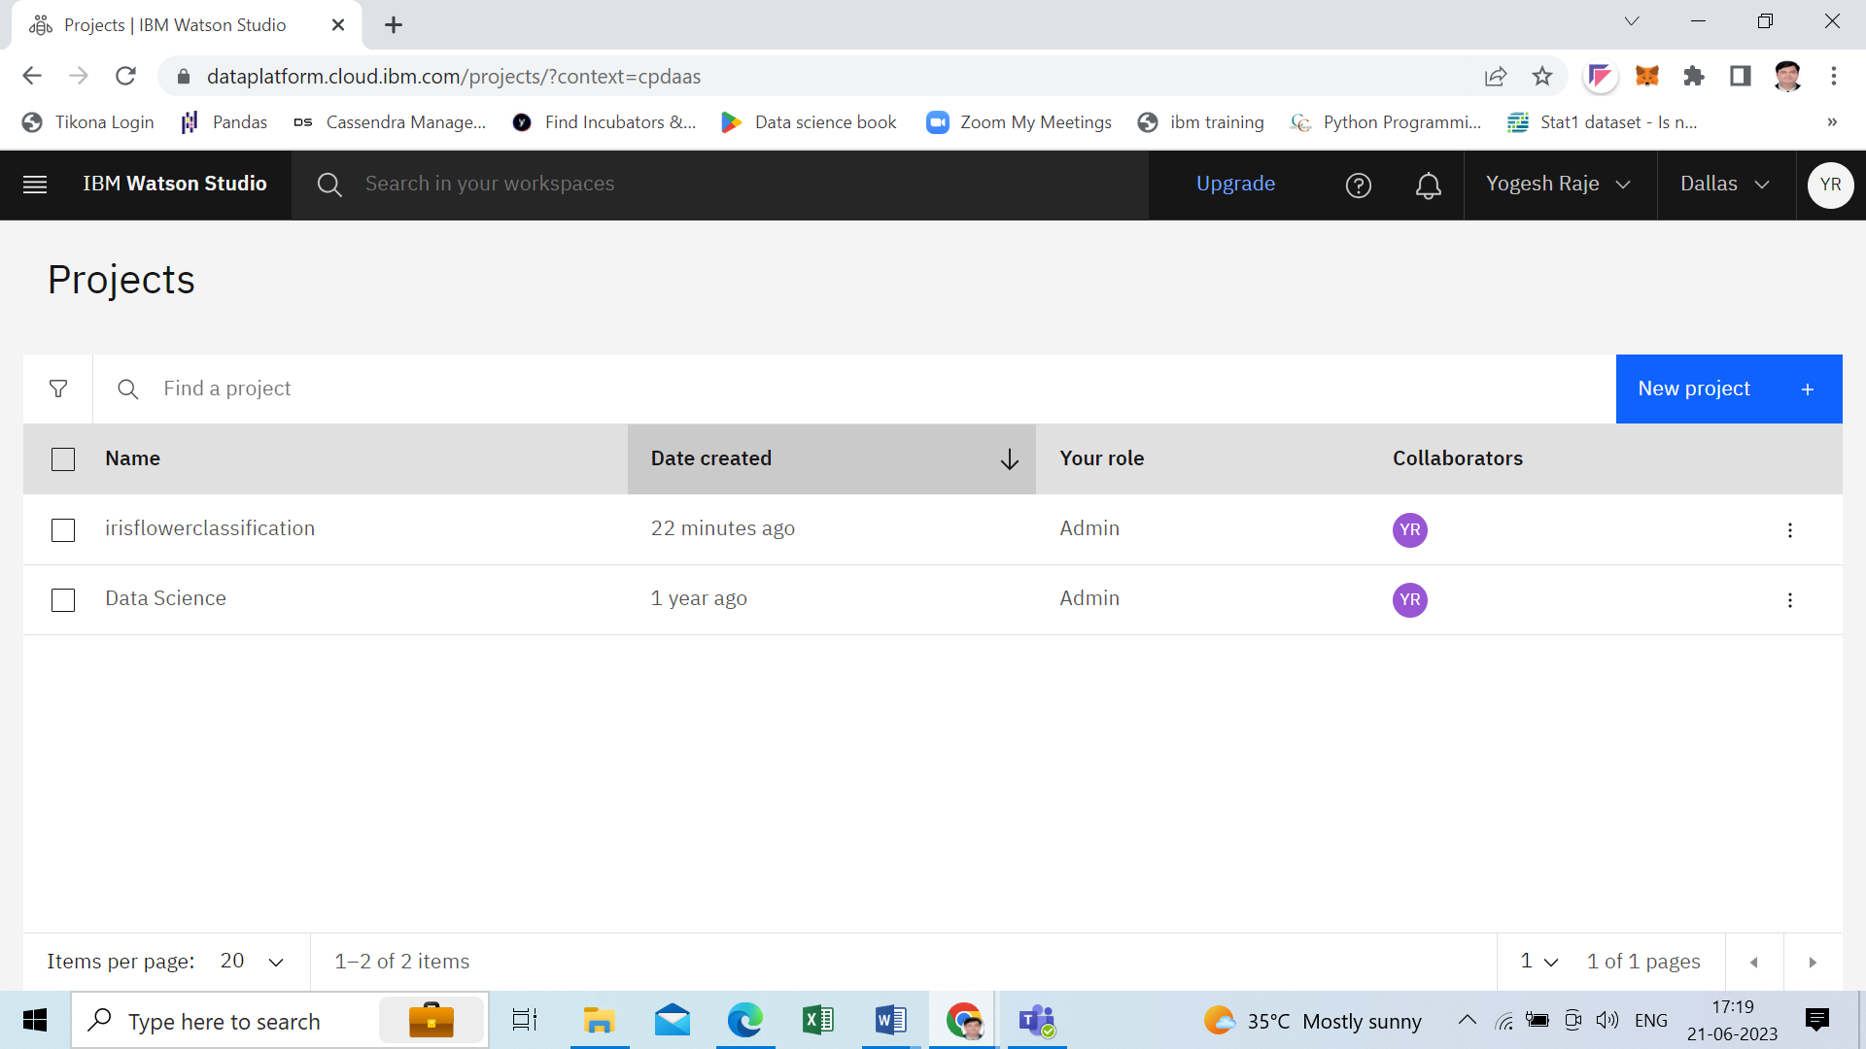

**Congratulations! You successfully created your machine learning model using IBM Watson studio.**